“Alone we can do so little;
TOGETHER
we can do so much.”

2018-2019 Annual Report
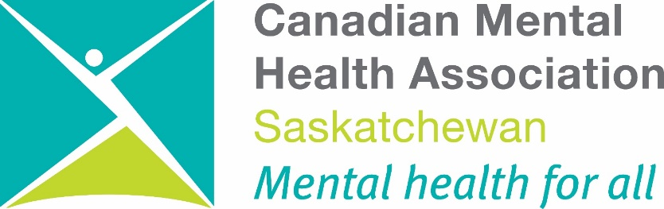

CMHA Saskatchewan has been in existence for 69 years (recognized as the first provincial division on November 27, 1950).
Canadian Mental Health Association
National Since 1918 Saskatchewan Since 1950

The “ERAS” of CMHA: Education, Research, Advocacy, Services
Throughout its history, the Canadian Mental Health Association has focused on Education, Research, Advocacy, and Services to improve the lives of persons with long-term, severe mental illness and to promote mental health for all. Often the actual work is done behind the scenes, through meetings, briefs, presentations, and personal interactions to propose and promote improvements in policy, programs, and resources. Key players include people living with mental illness, families, peer support and self-help, the informal and formal mental health service providers, planners, and policy makers. CMHA works through partnerships, collaborations, and coalitions to empower all sectors to take responsibility and leadership to improve mental health in communities.

These priorities are represented by the programs in Saskatchewan active in 2018:

EDUCATION
- Caregiver Affected Recovery Education (C.A.R.E.)
- Development of Online App
- Friends for Life Suicide Prevention and Intervention
  - Gambling Awareness Program (GAP)
  - Living Life to the Full (LLTTF)
    - Mental Health Week
- Pamphlets and Speakers
  - Provincial and National Conferences
- Website and Social Media
  - Writing for Your Life (WFYL)

RESEARCH
- History and archives of CMHA
- Poverty, housing, social recreation and other factors as
mental health issues
- With Saskatchewan Human Rights Commission and the Children’s
Advocate re: systemic discrimination in mental health
  - With Sask Métis Nation
- With Sask Polytechnic re: psychiatric nursing education
and workplace wellness
  - With U of R Community Research Unit/Lab

ADVOCACY
    - Disability Income Support Coalition (DISC)
  - With individuals re: income support, housing, as well as access to
mental health and community services
    - Saskatchewan Mental Health Coalition (about 200 groups)
      - Surveys, policy papers and press re: ongoing
and emerging issues

SERVICES
- Branches at Battlefords, Estevan, Rosetown, Melville,
Moose Jaw, Prince Albert, Regina, Saskatoon,
Swift Current, and Weyburn (a range of programs)
- Justice Community Support Program (JCSP)
[workers in 3 communities]
- OSI-CAN support groups around the province and by telephone
  - TRANSITION magazine

Read this Annual Report for more information about these programs and other aspects of CMHA.

Table of Contents
Global Ends Policy and Mission Statement 1
Values 2
President’s Report 3
Executive Director Report 4
Advocacy, Research & Public Policy 5
Public Education and Awareness 7
C.A.R.E. 7
Friends for Life 8
Gambling Awareness Program 9
Healing Through Humour 11
TRANSITION Magazine 12
Website and Social Media 12
Individual and Family Support 13
Justice Community Support Program 14
OSI-CAN 17
Our Branches
Battlefords 19
Rosetown 21
Melville 22
Moose Jaw 23
Prince Albert 24
Regina 26
Saskatoon 29
Swift Current 30
Weyburn 32
Resource Development 35
Financial Statements
Our Sponsors

Provincial Board of Directors

Chet Hembroff, President
Sharon Lyons, Past President
Grant Rathwell, Vice President
Bryan Leier, Treasurer
Jasmine Beriault, Member at Large
Karen Gibbons, Member at Large
George Marshall, Member at Large
Marcie Nugent, Member at Large
Kyle Moffatt, Member at Large
Myla Wolbaum, Member at Large
Darrell Downton, Regional Delegate
Susan Grohn, Regional Delegate
Michael Halyk, Regional Delegate
Erskine Sandiford, Regional Delegate
Debra Charuk, Regional Delegate
CMHA Saskatchewan Division Office Staff

Phyllis O’Connor, Executive Director
Dave Nelson, Senior Program Consultant
Don Powers, Director of Finance & Administration
Sharon Wilson, Executive Assistant
Sarah Dagenais, Clerk
Vera Thompson, Resource Development Coordinator & Telefund Office Manager
Sharon Saip, Resource Development Assistant
Donna Bowyer, Director, Friends for Life
Shauna Altrogge, Director, Gambling Awareness Program
Kathy Moorman, Northern Gambling Awareness Coordinator
Katelyn Selanders, Southern Gambling Awareness Coordinator
Jenna Lothammer, Central Gambling Awareness Coordinator
Daniel Blondeau, Communications Coordinator
David Jones, Director, Justice Community Support Program
Lesley Aimoe, Justice Community Support Worker (North Battleford)
Lisanne Hounjet, Justice Community Support Worker (Saskatoon)
Garrett McNaull, Justice Community Support Worker (Regina)
Megan Dubinak, Justice Community Support Worker (Creighton)
Julius Brown, Provincial Coordinator, OSI-CAN
Rebecca Rackow, Director of Advocacy, Research & Public Policy Development

Global Ends Policy and Mission Statement

The Canadian Mental Health Association (Saskatchewan Division) Inc. is a volunteer- based organization which supports and promotes the rights of persons with mental illness to maximize their full potential; and promotes and enhances the mental health and well-being of all members of the community.

Our Vision:
Mentally Healthy People in a Heathy Society

Ends Policy 1 QUALITY OF LIFE

People with mental health problems will have healthy, personally satisfying relationships and an excellent quality of life. Such a life includes meaningful work, adequate income, good housing, accessible education and training, enjoyable recreational activities, friendship and fun with others. It also includes easy access to appropriate, effective, comprehensive health services in a community in which there is an understanding and acceptance of mental illness.

Ends Policy 2 PROMOTION AND PREVENTION

There will be a reduced incidence and severity of mental illness in the community, mental health will be promoted throughout the community and high-quality information on mental health and mental illness will be available to all.

Ends Policy 3 AUTONOMY AND HUMAN RIGHTS

People with lived experience of mental illness, and families affected by mental illness, will be empowered and supported in their efforts to protect their human rights, and to freely make autonomous, reasonable and responsible choices and decisions.

Our Key Values and Principles
The Canadian Mental Health Association (Saskatchewan Division) Inc. endorses the following values essential to fulfillment of the Global Ends Policy/Mission Statement:

- Advocacy – Embracing the voice of people with mental health issues.
- Promoting Inclusion – focusing on mental health issues of all people
- Working Collaboratively – nurturing mutually beneficial partnerships with CMHA nationally, provincially and with CMHA branches as well as other mental health and disability groups and organizations working to move the issues of mental wellness forward.
- Social Wellbeing – influencing the social determinants of health. (e.g. housing, justice, contributing to mental health.
- Evidence Based – using evidence to inform our work and to innovate
- Transparent and Accountable - to our funders, partners and those we serve.

President’s Report
Chet Hembroff

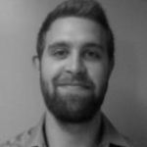

This has once again been a busy year for CMHA Saskatchewan Division. The Division has 10 branches located throughout the province, and has direct responsibility for the operation of 4 branches. As well, we lead four province wide programs: Gambling Awareness Program (GAP), Friends for Life, the Justice Community Support Program, and Operational Stress Injury – Canada (OSI-CAN). These continuously expanding programs have provided invaluable support to many residents, even targeting populations that have often been overlooked.

Once again we offer our many thanks for the dedication and hard work of our Executive Director, Phyllis O’Connor, everyone at CMHA Sask. Division, and each of the Branch Directors and their staff. The tireless efforts that our team exhibits to ensure that the mental health needs of Saskatchewan’s residents are recognized, important, and supported is worth considerable praise.
This year has been another positive year as CMHA Sask. Division continues to provide and expand mental health supports and programs. Our Research and Public Policy team, Dave Nelson and Rebecca Rackow, have continued to receive funding for various research projects investigating the mental health of our Saskatchewan residents, including our often over-looked Indigenous population. The Justice Community Support Program has become an integral component of the Saskatchewan justice system, serving our major centres, as well as a recent expansion into Creighton. OSI-CAN continues to grow and receive national recognition. OSI-CAN has been recognized for filling a gap in service for public safety personnel that has been neglected for too long and will now be expanding into Manitoba and Alberta communities. The success of OSI-CAN demonstrates the need for such programming and many thanks go out to the late Chris Siddons, the first Program Coordinator of OSI-CAN, who contributed a great deal to the development and expansion of this program.
This year has involved many increases in mental health funding. Although these increases may not be enough to fill in all the gaps in mental health service provision, these are very positive steps in the right direction. Such funding has provided the opportunity for CMHA Sask. Division to continue to provide and expand important mental health services, as well as the opportunity to provide salary increases to their staff for the first time in several years. I would also like to commend our own Swift Current branch for winning a national philanthropic contest and a prize of $125,000 in funding.

On behalf of the Board, I want to thank our Executive Director, the Sask. Division staff, and our Branch Directors and staff for the work that they do each year in support of people with mental health concerns. Whether it is fundraising, accounting, program management, or providing and examining service needs, these efforts continue to improve the quality of life and mental health in Saskatchewan. Successes big and small, for individuals and for communities, are all worth celebration and praise. Thank you everyone for another year of hard and important work!

Executive Director’s Report
Phyllis O’Connor
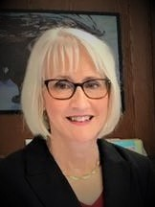
Another year has passed and it was a year of opportunities and growth for CMHA Saskatchewan Division.
On January 12, 2019 the CMHA Saskatchewan Division Provincial Board adopted a new three-year strategic plan entitled “Reflecting Back, Moving Forward – A Strategic Plan for CMHA Saskatchewan Division.” A copy of the strategic plan can be viewed at:
https://sk.cmha.ca/about-cmha/.
I have also had the opportunity to participate as a member of the CMHA National Provincial Executive Team in providing input to the new CMHA National Strategic Plan. Work is currently still under way.
In July 2018 Rebecca Rackow formally joined the team at CMHA Saskatchewan Division as our Director of Advocacy, Research and Public Policy Development. In November of 2018 she and Dave Nelson, Associate Executive Director, had the opportunity to meet with the Executive Director of CMHA Manitoba Division and staff of the Canadian Human Rights Museum in Winnipeg. They made a number of recommendations being presented regarding the mental health and addictions component of their displays. This resulted in CMHA being added as a stakeholder consultant as the work moves forward in this area.
Rebecca and Dave have also been involved in several research projects such as the Saskatchewan Polytechnic Research Project which explores the relationship between mental wellness and recovery in the workplace as well as development of the Refresh Wellness app. They also developed and submitted a proposal for a CMHA Métis Mental Health and Addictions Program for Saskatchewan. This proposal was accepted and the first year consultation and research component is currently under way. CMHA Saskatchewan Division now also has representation on the Western Canada Métis Addictions Council Saskatchewan.
In January 2019 we were excited to open our newest CMHA Branch in Rosetown, Saskatchewan. Carmen Ledding has joined our team as the Branch Coordinator and she has been very busy setting up the office and getting all the training she will need to provide the mental health education services in Rosetown and area.
Our Justice Community Support Program has now expanded into the north with a JCSP worker established in Creighton, Saskatchewan. This will be a busy time making connections and setting up partnerships in this new area.
We were also excited to have our OSI-CAN program expand into Manitoba in early 2019. We are also currently in the process of starting the expansion into Alberta and hopefully by the end of 2019 some groups will be up and running there. This has been an extremely successful program in helping our veterans and community first responders suffering from an occupational stress injury to move forward in their recovery. Discussions continue with CMHA National regarding a possible national rollout of the program.
Our partnership with Service Hospitality continues to flourish and we are getting mental health in the workplace information out to over 4,000 businesses in Saskatchewan. Through this partnership the “Difficult Discussions – Managing Mental Health in the Workplace” training was developed. This is a brand new training program that offers attendees a safe way to practice their skills through the use of professional improv actors and scenarios that reflect real situations that may arise in the workplace. The CMHA National Workplace Director has conducted some research and was unable to find anything like this training in Canada. It is also being considered for rollout as a CMHA National training program.
We are also proud to have CMHA National ask CMHA Saskatchewan Division to take on the CMHA Certified Psychological Health and Safety Advisor training in Saskatchewan. This is an amazing opportunity and the first training is scheduled for June 2019.
There is so much more going on and individual program and branch reports will go into more detail. CMHA Saskatchewan Division is always looking to form new partnerships and to take advantage of new opportunities to advance the work of pushing mental health forward in our province.
Advocacy, Research & Public Policy Development Report
Rebecca Rackow & Dave Nelson
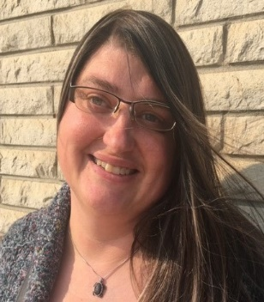
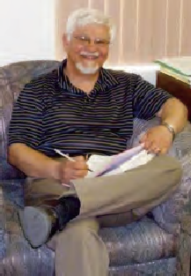
In July 2018, the Advocacy, Research & Public Policy Development program was formed. There are three aspects of this program that are all related to enhance the big picture of mental wellness in Saskatchewan. Individual callers looking for advocacy informs the directions taken in research projects. The data from research projects as well as information supplied by individuals give direction to large scale, systemic advocacy and public policy directives. Here is a breakdown from each of those aspects:

Individual Advocacy

We have a number callers requesting advocacy. The bulk of these callers can be placed in these groups:

- Requests with help with the legal system,
- Requests with psychiatrist visits,
- Requests for workplace accommodations/mediations,
- Requests for insurance claims/mediations,
- Requests for help navigating the SAID program,
- Requests for help navigating housing,
- Requests for help with Worker’s Compensation claims,
- Needing a listening ear to avoid a crisis situation.

Research Projects

Rest assured: Changes to the Saskatchewan Assured Income Support Program and the impact on beneficiaries. On behalf of the Disability Income Support Coalition, this project responds to the outcry organizations are hearing and interviews SAID beneficiaries on impacts of recent cuts to the SAID program. Funded through the Community Research Unit and working with the University of Regina’s Social Work Researcher, Dr. Randy Johner.

Recovery from mental health challenges and illnesses at the workplace “Challenging Leadership to Re-define Organizational Culture”: Working in partnership with Saskatchewan Polytechnic’s Psychiatric Nursing Research Team and Refresh Inc., this is a mixed method longitudinal study that involves both persons with lived experience and caregivers and explores what effect outside programs have on workplace wellness over the span of a year. Funded through NSERC’s CCSIF grant.

A project for Métis mental wellness in Saskatchewan: This involved interviewing individuals and groups/communities to determine what is currently working and not working for Métis people to access mental health services in Saskatchewan. This is funded by Métis Nation Saskatchewan and involves data collection to better understand Métis citizens’ needs as well.

Recommendations for recovery: Lived experience with operational/occupation stress injury with the Worker’s Compensation Board: Funded internally through OSI-CAN and funds through partnering with the WCB, this project involves open-ended surveys of OSI-CAN participants who have dealt with the WCB. The University of Regina’s Anxiety and Illness Behaviour Laboratory, with Dr. Nick Carleton and faculty of Social Work’s Dr. Douglas Durst are working with us on this task.

Needs in the North: A community-based exploration of disability service needs in northern Saskatchewan: The Disability Services Alliance (DSA) is a newly formed group of mainly Executive Directors and CEO’s of the CNIB, Inclusion Saskatchewan (formerly SACL), Saskatchewan Deaf and Hard of Hearing, Sask. Abilities Council, Parkinson’s Society, Spinal Cord Injury of Saskatchewan, Saskatchewan Voice of Persons with Disabilities, and CMHA, all brought together with the Human Rights Commissions Director of Systemic Initiatives. There has been difficulty getting adequate and appropriate services to Northern Saskatchewan, so we set out to ask what that looks like in order to create Pilot Disability Service Hubs, run by local people in a few communities. We are going to these communities and requesting knowledge.

Systemic Advocacy

Advocacy, Research & Public Policy Development program has also done systemic advocacy in the following ways and activities:

- Work with the Human Rights Commission of Saskatchewan on housing for those with cross-disability needs including those with psychiatric disability needs.

- Work with the Human Rights Commission of Saskatchewan on concerns regarding cuts to the SAID (Saskatchewan Assured Income for Disabilities).

- A meeting with the Human Rights Museum in Winnipeg, the Manitoba CMHA Division and the CMHA National office in November 2018. This was a meeting to discuss ways in which depictions of Human Rights issues regarding mental illness cases be improved. We are working on an ongoing basis with the Museum to ensure improvements are in place.

- Collaborative efforts with the DISC (Disability Income Support Coalition) to ensure improvements to the SAID program.

- Dave Nelson has been co-chair of the PIAT (Program Implementation Advisory Team) for the past two years. This group has worked collaboratively with the Ministry of Social Services. This group has been wound down effective June 2019 and we are working to ensure input regarding the SAID program.

- Meetings with Scott Livingston, CEO of the Saskatchewan Health Authority to discuss our thoughts on the needs of the mental health and addictions system, as well as meetings with Kim Kratzig, Assistant Deputy Minister of Health.

- A recent meeting with the Minister of Health was very productive. A presentation of our new “My Electroconvulsive Therapy Handbook” and the “Sun West School Division proposal of mental wellness 30L Program” were well received by Minister Reiter. Future meetings to discuss mental health needs are being planned.

Public Policy Development

As part of the CMHA National Public Policy Work Group, Rebecca has received and made comments on such national position papers as “A Bold Way Forward”, A Framework for Action 2018, “Mental Health in the Balance”, “Ending the Health Care Disparity in Canada” and the “Mental Health Promotion Paper”.

By request of various government departments both provincially and federally, we have also submitted position papers on “Cannabis at the Workplace” and “Gun Control and Mental Health Issues”. We have also made policy recommendations for a collaborative care model of provincial mental health services “A Responsible Vision and Plan for Mental Health and Addictions Care in Saskatchewan” based on a World Health Organization model to reduce wait times and stretch funds.

PUBLIC EDUCATION & AWARENESS

CAREGIVER AFFECTED RECOVERY EDUCATION (C.A.R.E.)
Rebecca Rackow, Research & Public Policy Development

There has been increased interest in the Caregiver Affected Recovery Education program. A presentation to the Disability Services Alliance has generated some of this interest and Inclusion Saskatchewan (formerly SACL), the Canadian National Institute for the Blind (CNIB), and Spinal Cord Injury of Saskatchewan have all inquired into offering the workshop to employees, families, and other caregivers within their organizations. C.A.R.E. also went to Moose Jaw to talk to peer supporters about the dangers of Compassion Fatigue, Burnout, and Vicarious Trauma in self or others and then a guideline on how to prevent or recover from these issues.

The C.A.R.E. program continues to be an integral part of the methodology for research projects involving caregiver supports. One main project involves our continued partnership with the Psychiatric Nurse Research Team at Saskatchewan Polytechnic. This is a project that has received some NSERC funding.

The C.A.R.E. program is also pleased to announce that there have been recently ten participants in a workshop event completed the C.A.R.E. training and are connected to supporting each other. We have also been in talks with professional organizations (such as SUN) to advance the workshops to offer Continuing Education Units (CRUs) which, at .1 units per hour, would give our professional caregiver participants one full CRU. We also have a team of consultants and volunteers committed to seeking future funding opportunities and facilitate future workshops to educate Saskatchewan’s caregivers.

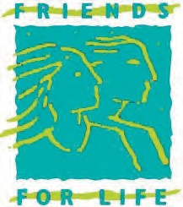
FRIENDS FOR LIFE
Donna Bowyer, Director

Once again this was a busy year. I did an average of 6 - 7 presentations a month, varying in length from one hour to two days. I wasn’t able to do as many displays as I had in the past, but through the support of the Branches we had a visibility even when I wasn’t available. I appreciate that whether it was a display or a presentation that needed to be done, I could just contact the Branch and ask if they are able to do it. Most of the time the Branches found a way to accommodate the requests.

What I noticed the most this year is that, more of the Branches are getting involved in ways that we had not traditionally been involved. There are more Branches now going into the community to do more training, and recognizing other avenues besides direct service that they can be involved in. This year when I received a contract to do training for one of the Government Departments that wanted to do training in three different centres, I was able to contact two of the Branches that have trained staff to deliver the training in their own community. It was great to have the partnership and work with the local Branches to get the job done in the best way possible. Once again, it feels like we are one organization working together. Thank You.

Each of the Branches has unique skills and interests, and yet we are starting to get some consistency. I know that National has been talking about ‘flag ship trainings’ that we can do throughout the country, and I have seen some of that happening in Saskatchewan. I see throughout the Province some standardized training available in multiple communities. We have Mental Health First Aid in three of our Branches, ASIST trainers in three Branches, safeTALK trainers in three Branches, Living Life to the Full trainers in two of our Branches…. And these may have changed by the time this is read.

Offering training is something that I see more and more across our National CMHA Branches, with the general flag ship training that we have traditionally been offering, and also in Alberta and Manitoba with the Recovery Colleges. Each of the provinces has taken a different perspective, and I think that if we decide to move in this direction, that we have our own version but still be within the philosophy of providing training to our members and the community that will promote skill building and recovery.

The training we do makes a difference. It’s sometimes hard for us to know if it does or not, but on occasion, we do hear back from someone about their ‘aha’ moment. I had some civilians that worked in the military attend one of my MHFA sessions. About a week after the training, I ran into one of the participants. She said that she had taken the training because it was mandatory but didn’t really expect to learn anything she hadn’t already known. The training was on a Tues/Wed. She said on Friday one of the men walked into her office and from what he said, the training kicked in, and she recognized that he was struggling with what she thought might be PTSD. She asked him about how he was feeling, and he broke down and cried because she was the first to recognize his distress. She said she knew that she would not have recognized or asked, had she not taken the training.

On another occasion, I was returning to the same workplace to do training. A woman walked by and saw me in the training room and came in. She said she had taken the training on a previous date, and thought she would never need it, but she had used it twice since then, and wished she had taken it years ago, because she recognized all the times she had missed what to her, was now obvious.

There are many stories that we hear about the training we do, and it supports the need to go out and do the training because we do make a difference. I have many stories about how taking the Living Life to the Full has changed peoples’ lives; some in little ways and some in major ways. With each story, they show how they appreciate what they have learned because it increases their quality of life.

Sometimes, I receive a call and wonder how they got my phone number, or email. It is because, when we make a difference in peoples’ lives, they remember and want to share with people they feel would value the knowledge we are sharing with them. They, in turn, are able to enhance the quality of life for the people around them.

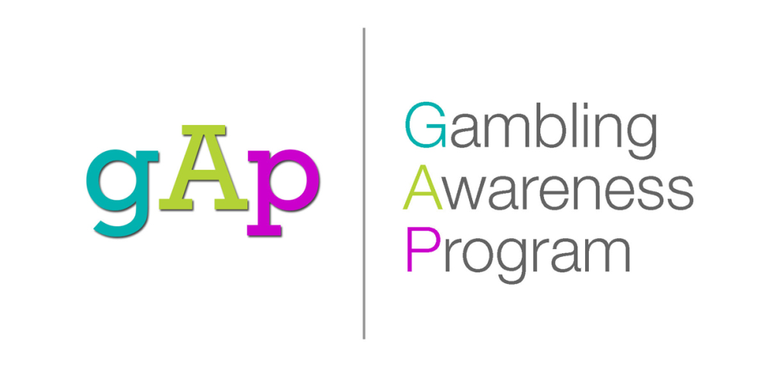

Shauna Altrogge, Director
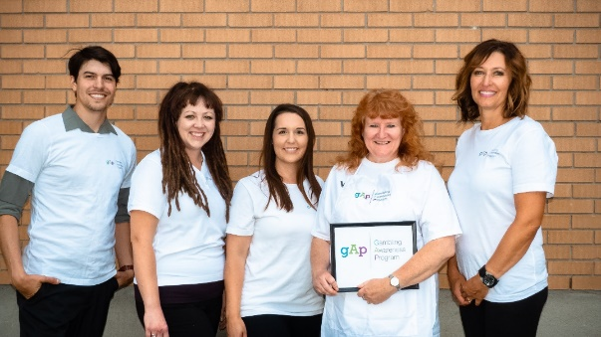

The Gambling Awareness Program (GAP) is a long-standing program of the CMHA SK Division, and in fact, next year we kick off our 25th year of service provision. The staff are both humbled and excited to continue this important work. HAPPY 25th Anniversary GAP! The following are some key highlights from this year:

What is 353? Another record for the Program! We delivered 353 community-based presentations across the province, talking with 7,328 people, with over half being delivered to youth. GAP sessions align with curriculum, include content around video gaming and gambling, and support learning by engaging students with fun games and allowing opportunities for reflection and self-exploration with What’s Your Gaming Profile? scratch card. Clearly, talking video games with kids is a great segue that opens the door for meaningful conversation around other addictions and mental health issues. Interestingly, this year the World Health Organization recognizes “gaming disorder” in the 11th Revision of the International Classification of Diseases (ICD-11), joining the American Psychiatric Association (APA), which had previously added “internet gaming disorder” as a phenomenon worthy of more research in the Diagnostic and Statistical Manual of Mental Disorders (DSM-5).

GAP’s social media and advertising strategy continues to grow and evolve, with considerable effort and planning by our Communications Coordinator. The Program recognizes the value in creating our own videos, making us more identifiable, approachable, interactive, and noting how video consumption is becoming the new normal on social media, with the potential to reach larger audiences. Adopting this approach, and connecting with youth via Instagram may be an effective strategy moving forward. GAP launched www.SaskGAP.ca this year as a way to make GAP’s website more easily accessible, simpler to navigate with an enhanced lay-out, updated pages and content that reflects current trends and program highlights.

Our work with the RCMP Cadets, Métis Addictions Council of Saskatchewan Inc., Radius Community Centre, YWCA, Impaired Driver Treatment Centre, Pinegrove Corrections, Bridges to Employment, ESP for Youth continued on a regular basis. This year we expanded our outreach to include some new groups: Pathways to Wellness, Southwest Newcomer Welcome Centre, Sask Abilities, The Lighthouse Supported Living, Crocus Co-op, PTSD Support Group, Flying Dust First Nation, Saulteaux First Nation, Sask Polytecnic’s Indigenous Summer Transition Program, Hopeview, Catholic Family Services, Paul Dojak Youth Centre, Parkland College, and the Saskatchewan Hospitality and Service Association (SHSA).

Meaningful connections were made with hundreds of Saskatchewan folks, and through our outreach efforts, 53 individuals disclosed a gambling problem. They were subsequently provided information and referred to the Helping Services. We wish them well on their recovery.

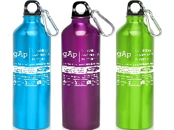
Setting up the identifiable GAP Display, complete with tall banners, helping resources, interactive games to help open up conversation, along with giveaways such as the GAP water bottles, was an integral part of GAP’s outreach. This year we attended 26 events, and connected with 2,600 people at such events as Awasis, YXE Connects, Saskatoon Blades “Stick it to Stigma” in partnership with the CMHA Saskatoon Branch, Saskatchewan Safety Council, and visited a number of post-secondary institutions, casinos, teacher conventions, and schools.

Counter-intuitive to popular thought, GAP has reinvented the wheel. Yes, GAP is bringing the popular spinning wheel back into circulation, with newly designed graphics and refreshed categories that reflects the modern gaming and gambling landscape. Important topics such as video gaming, loot boxes, and sports betting will compliment the range of topics we cover during community outreach activities.

Grantor Get Together! The Director delivered a presentation to the Community Initiatives Fund Board of Trustees, our primary funder, as the year came to a close. The session provided an overview of gambling in Saskatchewan, modern gaming trends, problem gambling impacts on our communities, how GAP makes a difference, and shared some Program successes and challenges. The Board of Trustees expressed interest in expanding the presentation for employees at the Ministry of Parks, Culture and Sport, and will also be featured in a future edition of their E-Newsletter and on their social media platforms. The CIF approved funding for 2019-2022 so we are looking forward to another three exciting years!

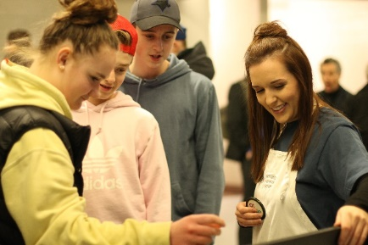
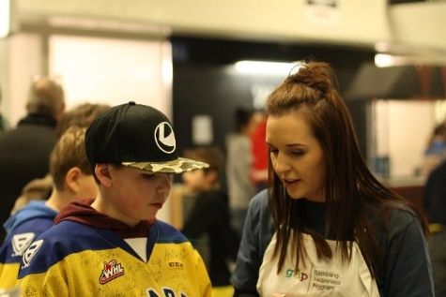

GAP

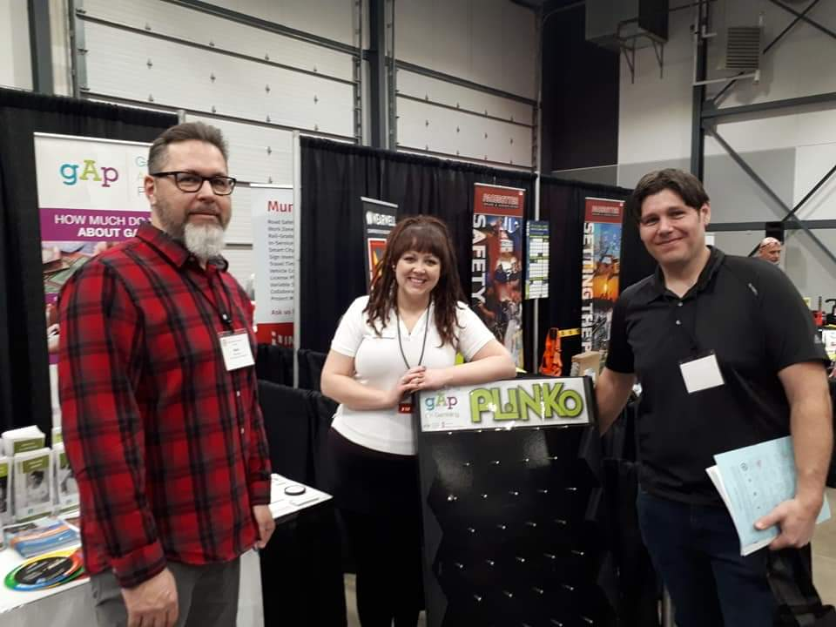
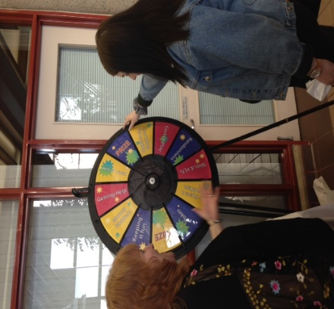
“It provided me with additional knowledge on the concept as well as an alternative perspective towards the mechanisms behind gambling.” –U of S Abnormal Psych Student

“It provided me with additional knowledge on the concept as well as an alternative perspective towards the mechanisms behind gambling.” –U of S Abnormal Psych Student

Ian Morrison Program Facilitator

Healing through Humour is a program run through the Canadian Mental Health Association of Saskatchewan Division in partnership with the Schizophrenia Society of Saskatchewan. The program teaches people living with mental health issues the art of comedy writing and performance. In the past year we released another musical comedy album with three music videos as well as being in preproduction for a sketch comedy piolet performed by puppets. The voices of the puppets will be portrayed by the members of Healing through humour. We also had another great show with some new performers in October as well as having multiple musical guests to ensure a great show. We hope to continue creating over the next year and bring you lots more exciting updates in the near future. Visit our website at www.healingthroughhumour.com and like us on Facebook.

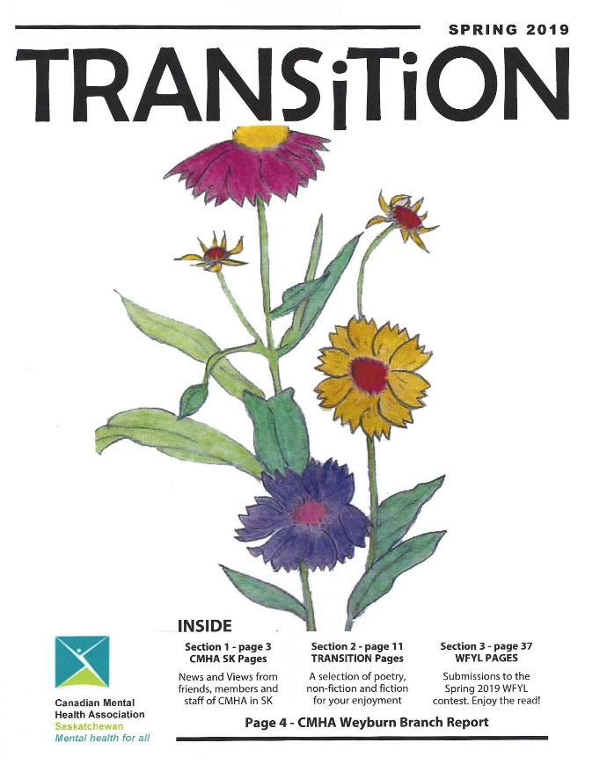

Transition Magazine
Transition Magazine is published twice a year. It is distributed free of charge to members of CMHA Saskatchewan Division, to CMHA Divisions and Branches across Canada, and to community-based and government organizations in Saskatchewan who have an interest in mental health/mental illness issues. Transition Magazine is also made available in PDF format on the CMHA Sask. Division website at http://sk.cmha.ca/documents/transition-magazine/

Transition publishes two kinds of works: those directly about current mental health issues and those about the individual’s personal experience of those same issues. Both kinds of work celebrate lives in transit—lives of change, growth, and transformation.

Website and Social Media
CMHA Saskatchewan Division’s online presence includes the following mediums:

- Website: https://sk.cmha.ca

- Facebook: https://www.facebook.com/CMHASK/

- Twitter: https://twitter.com/CMHA_sk

- Instagram: https://www.instagram.com/cmha_sk/

Check them out to get the latest news, events, and information on a variety of mental health topics!

Programs and Services

INDIVIDUAL AND FAMILY SUPPORT

While the main focus of the work of CMHA (Saskatchewan Division) Inc. is education and public policy development on a provincial scale to assist those experiencing mental health issues, the staff at CMHA Saskatchewan Division Office frequently have the opportunity to assist individuals, consumers and their family members on a wide variety of issues.

The following illustrates the type of assistance provided by the CMHA Saskatchewan Division Office staff throughout the past year.

- It should be noted that our OSI-CAN PTSD Support Project for Veterans and Community First Responders also receives approximately 7 calls per week for information and support.

The above is just an overview of the type of requests for individual and family support received at Division Office on a regular basis. Division Office staff also provide verbal and print information on a wide variety of mental health topics such as schizophrenia, bipolar disorder, depression, obsessive compulsive disorder, stress, workplace mental health and much more.

JUSTICE COMMUNITY SUPPORT PROGRAM (JCSP)
David Jones, Director

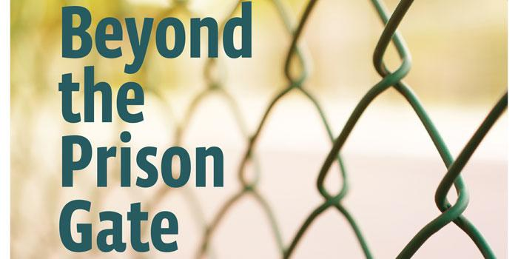
The Justice Community Support Program (JCSP) is a partnership between the Canadian Mental Health Association and the Saskatchewan Ministry of Justice Serious Violent Offender Response (SVOR) initiative. Set up in 2013, the SVOR is a comprehensive, targeted, and evidence-based approach on public protection by reducing the risk of past offenders being involved in serious, violent crimes. Various agencies within the justice system – such as adult corrections, public prosecutions, police services, RCMP – and this CMHA program collaborate on integrated case planning while leveraging innovative tools such as secure, web-based data management systems and regular training opportunities.
This initiative is currently operating in Saskatoon, North Battleford, Regina and most recently Creighton.

Our Program Staff – The JCSP Team!

Staff are focused on individual rehabilitation through the delivery of one-on-one support and the establishment of links with available community resources and programs. A client’s need for resources may include housing, income support, education and/or employment, crisis response, anger management and social recreation activities. Health needs may require getting on the case load of a general practitioner, the mental health clinic and psychiatrist, dentists, optometrists or other services.

The JCSP worker offers the client a period of intensive, interpersonal involvement to anticipate and resolve practical and emotional barriers to healthy living in the transition from prison to community. The client is encouraged to establish a positive community resource base to sustain the objective of “staying out of jail” beyond the transition of probation and the JCSP intervention. The well-being of the client improves the possibility for a crime-free future as a citizen contributing to personal and community success.
We welcomed two new faces to the Program!
Lisanne Hounjet has replaced Lisa Harder (on one year leave) in Saskatoon and is currently working with new Probation Staff. Lisanne commenced duties Jan. 16, 2019.

Lisanne Hounjet Saskatoon

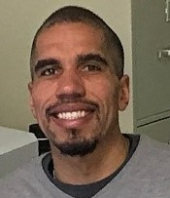
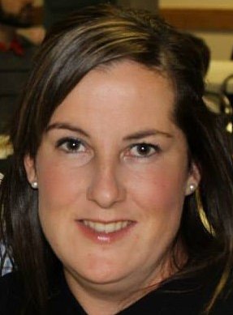
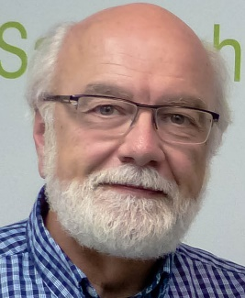

Garrett MacNaull
Regina
Lesley Aimoe
North Battleford
Lisa Harder
Saskatoon
David Jones
Director

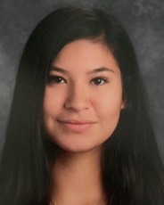

Megan Dubinak is brand new to the recently formed Northeast Serious Violent Offender Program (NSVOP) based in Creighton and in the partnerships venture to the northern part of the Province. These are new roles for all involved and a steep learning curve in meeting community needs. Megan commenced duties Feb. 19, 2019

Megan Dubinak
Creighton

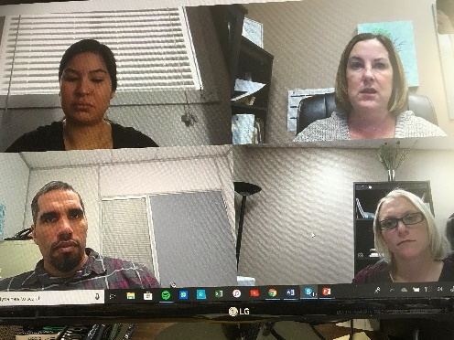
Team Skype Call Highlights of 2018

- The annual SVOR Information Day and Training was held in Regina in January. Excellent case management presentations from Saskatoon and North Battlefords provided the example for the soon to be established formal SVOR in Regina.
- And in February the first SVOR Admissions/Discharge meeting was held on the 12th floor board room of the Prosecutions Office. Simple trial and error process got us started and since all involved are fast learners – not to mention persistent – the program found its bearings fast!
- Appreciation to Lesley Aimoe (North Battleford) for developing an anger management module with resources shared with the Team. This aims to address the probation order that direct client to addressing anger issues.
- Continuing to develop a program image/identity that contributes to a professional and public representation of the program.
- Towards the end of the year, the JCSP welcomed Lisanne Hounjet to replace Lisa Harder who is on a one year leave of absence to discover the world of “remand” at the Edmonton Remand Centre.

Although technically in 2019 – the JCSP has the privilege of a University of Regina, Justice Studies student – Allie Somers - working with us. Allie is tasked with a research initiative exploring the challenges of housing for clients re-entering community – as well as learning all she can from shadowing staff! Allie also had the opportunity to take the Mental Health First Aid training during her time with us!

Goals for 2019:

- To establish the new North Serious Violent Offender Program (NSVOP) in Creighton and satellite communities of Pelican Narrows, Deschambault Lake and Sandy Bay. This promises to be an adaptation of the current JCSP considering the limited resources of these communities.
- Define and promote our specific and unique role of the program within the partnership. Continued vigilance is needed to maintain mental health focus and delivery.
- Maintain a visible program identity and clear role of mental health support and CMHA Vision

- For staff development, to set up a strategic coaching program specific to management partnership development. This is to be the focus of the learning strategy for 2019-2020.

JCSP Client List for 2018
Location | Accepted | Discharged | Current
Saskatoon | 19 | 20 | 14
North Battleford | 19 | 12 | 12
Regina | 10 | 6 | 10
Creighton |  |  | 5
Total | 48 | 38 | 41

In the end we will only be transformed when we can recognize and accept the fact that there is within each of us, quite outside the range of conscious control, a will which knows what is right for us, which is repeatedly reporting to us via our bodies, emotions, and dreams, and is incessantly encouraging our healing and wholeness. We are all called to keep this appointment with the inner life, and many of us never do. Fortunately, this insistent invitation comes to us again and again. - James Hollis

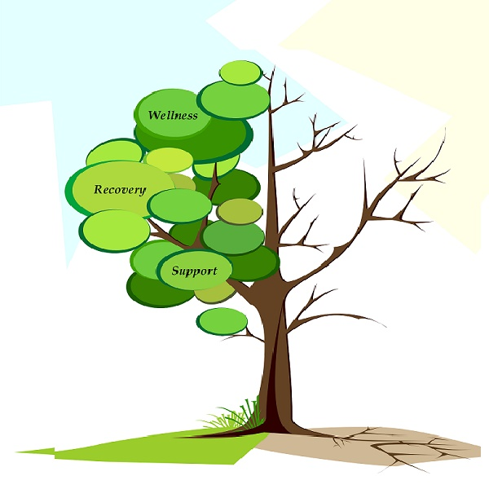
A common representation of life is symbolized through an image of a tree. We have adopted this image to represent a healthy life that includes the reality of traumatic experience. The principle themes of the program: Wellness, Recovery, and Support hold forth the potential of nurturing the life of the tree despite an ever present sense of emptiness and/or suffering. For the reality of both hope and despair are part and parcel of the recovery process

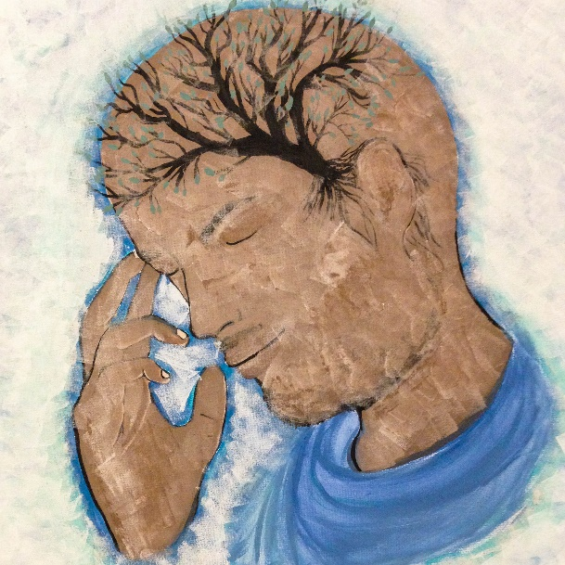
OSI-CAN (OPERATION STRESS INJURY/PTSD SUPPORT INITIATIVE)
Julius Brown, Provincial Coordinator
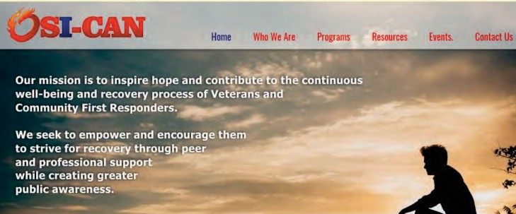
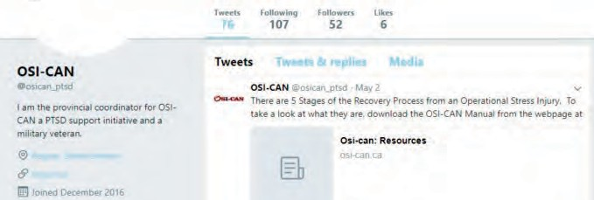
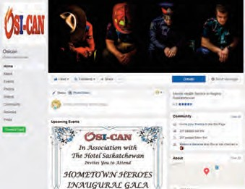
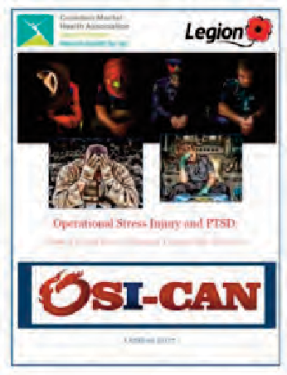
OSI-CAN, an Operational Stress Injury/Post Traumatic Stress Support Initiative, continues to provide hope, resilience and recovery to the men and women who serve our communities and country.
We were created in January 2016 as a partnership between the Canadian Mental Health Association Saskatchewan Division and the Royal Canadian Legion Saskatchewan Command.

Our target demographic consists of serving members and veterans of the Canadian Armed Forces, Allied Armed Forces, the Royal Canadian Mounted Police and Community First Responders or public safety personnel—which include Municipal Police Services, Emergency Medical Services, Fire Protection Services, Hospital Trauma personnel, Emergency Communications Specialists, Corrections Officers, Traumatic Accident Clean-up Crews and Volunteer First Responders. This demographic was chosen due to the commonality of experiences they share through the service they provide to country and community.

OSI-CAN seeks to empower and encourage our target group to strive for recovery through peer and professional support. Our initiative does not require participants to be diagnosed or referred. They just need to be willing to admit to themselves that they might need some help and find the strength to attend one of our support groups. Our support groups provide a secure and confidential forum that is built on anonymity. Here, their issues can be discussed with others who are going through the same thing without fear of judgement or criticism. It is within the support group that other needs are identified and addressed.

We have an ever-expanding network of service providers to link members with other services necessary for their recovery, such as housing, OSI counselling, addiction services, vocational training, psycho-social rehabilitation, advice on prescriptions, horse-assisted therapy, and financial assistance for those needing a service dog.

OSI-CAN also has a Family and Close Friends of those with OSI support group. It provides support and information on what is OSI, Trauma Informed Care and Self-care.

Our Phone-In Support Group is for individuals located in remote or hard to reach areas of the province or those with mobility issues that prevent them from physically attending a support group meeting.

OSI-CAN’s network of supports continues to grow as individual needs are identified and our program is free to anyone who needs it.

We offer coping strategies, self-care and symptom management. We also encourage use of the PTSD Coach Canada mobile app, which is a self-management app. Our objective is RECOVERY.

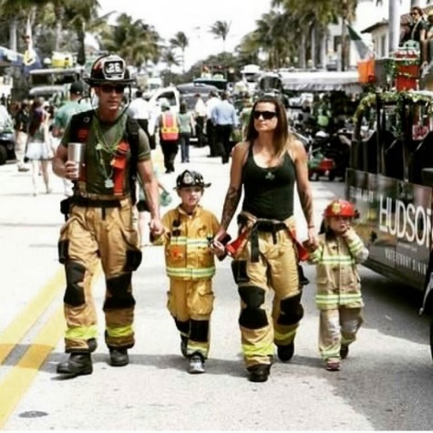

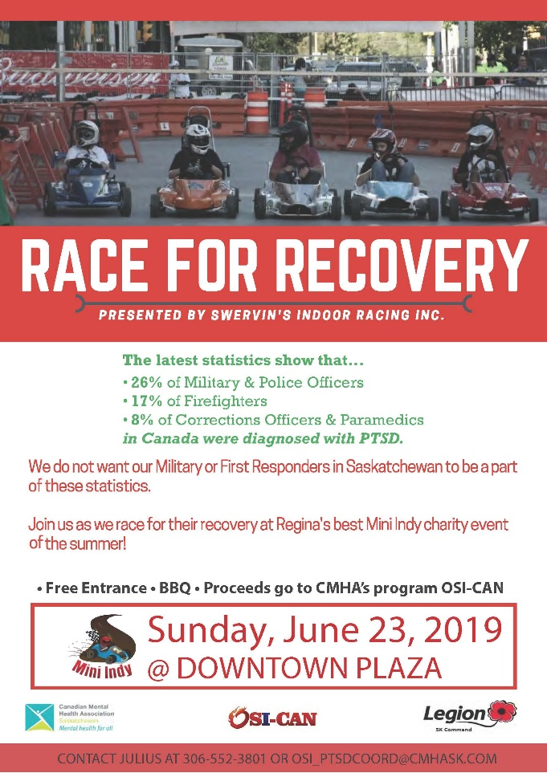
We currently have support groups operating in Regina, North Battleford, La Ronge, Prince Albert, Saskatoon, Moose Jaw, Weyburn, Tisdale, and Estevan.

OSI-CAN is funded primarily through private donations received from our communities, organizations and businesses. We are currently collaborating with the Workers Compensation Board on their program development while they provide OSI-CAN with partial funding for the year 2019.

OSI-CAN has a manual titled “Operational Stress Injury and PTSD: What It Is and How to Manage Trauma into Recovery.” This resource is available at http://www.osi-can.ca/resources.html

Follow us on our website (osican.ca), Facebook (osicanrecover), and Twitter (@osican_ptsd

BATTLEFORDS BRANCH
Jane Zielke de Montbrun, Executive Director

CMHA Battlefords Branch continues to provide programs, supports and services to people living with mental illness, their families, their friends and caregivers. New and ongoing projects include Recovery College, peer support, community education, awareness and fundraising.

Mental Health Week 2018

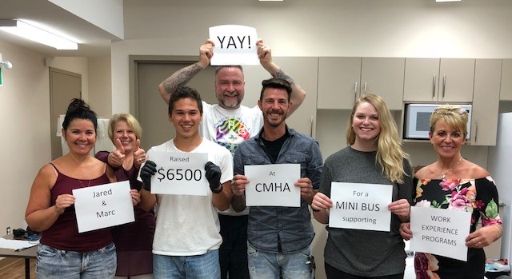
We kicked off Mental Health Week (MHW) 2018 with our annual flag raising ceremony at North Battleford City Hall. The program included honour songs by Young Bucks youth drumming group from Poundmaker First Nations. Battle River Treaty 6 Health Centre (BRT6HC) sponsored a free community BBQ with proceeds donated to our branch and The Lighthouse. Saskatchewan Hospital celebrated MHW 2018 by holding a Talent Show and many in our community joined us in our annual Walk for Awareness. Our 2nd Semicolon Tattoo event raised $6,500 for our latest project – a mini bus for work experience programming. We’re grateful to Marc’d Up Tattoos in Turtleford and Skinny’s Tattoo on 48th in Lloydminster for again working a really long day for our organization.

Garden Party
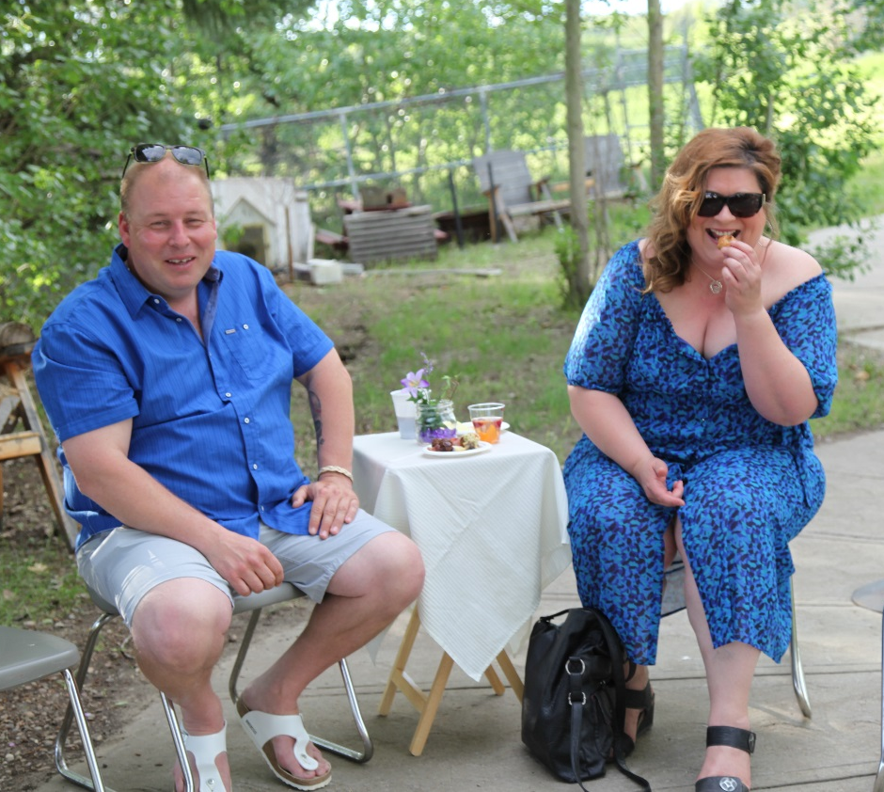
On June 16th, 2018 we held our second Garden Party after a decision by CMHA Battlefords Branch Board of Directors to hold an annual fundraising event. This event concept is new to our community. The Garden Party is held after a donation drive to thank our supporters – those donating $200 or more prior to the event receive an invitation to the Garden Party. Everything is free and no fundraising takes place during the evening. It’s a celebration of our organization and a gathering of like-minded people wanting to make a difference. There’s live entertainment, safe rides home and no shortage of food and drinks. We raised approximately $12,000 last year and are hoping to increase this significantly with our 2019 donation blitz and subsequent Garden Party event.

Our Programs

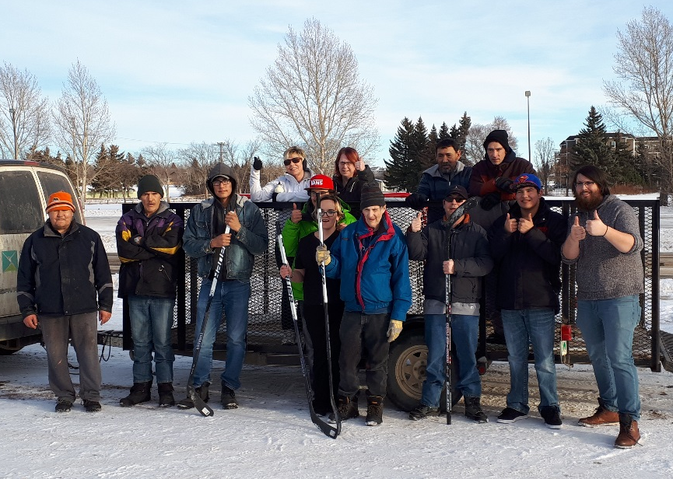
Social recreation programming continues to be popular. Members participated in evening and weekend activities offered 5 times/week throughout the year. Tour last year took a group of 28 members to Moose Jaw and Regina. Everyone enjoyed the Tunnels tours as well as other attractions in the area. We held two weekend camping trips to Battlefords Provincial Park. In total, this program’s participant count exceeded 2,300.

Life skills lessons are offered weekly and bi-weekly. In total, 36 individuals participate in this program on a regular basis. Our seniors’ program, with activities and outings tailored to this age group, is held two mornings a week and a summer program provides activities from mid-May to the end of August.
Shinny in December

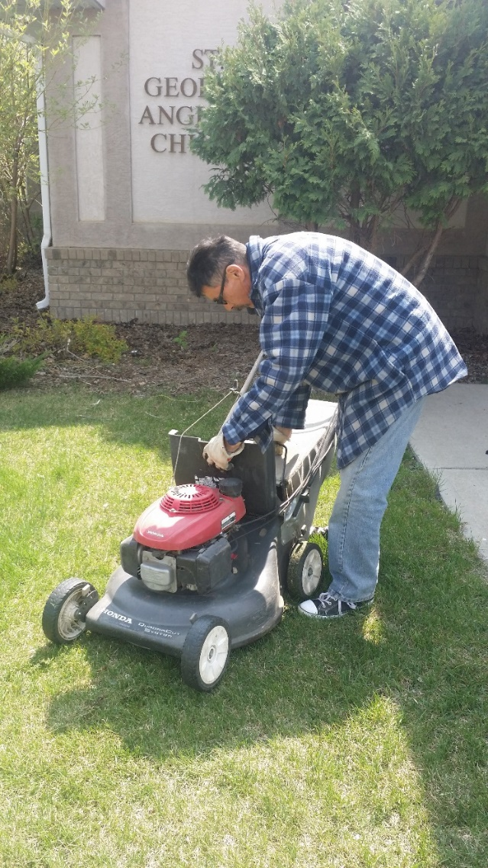
Our vocational programs (TEP) continue to engage more members in meaningful work in The Battlefords. In 2018-19, 20 TEP I members worked in the community shoveling snow, mowing lawns, delivering flyers and performing odd jobs. Our TEP II program offered work experience through job opportunities in housekeeping, newspaper delivery, janitorial work and grounds/facility maintenance at David Laird Campground. Participant count in TEP II this past year was 65.

This past year we welcomed 62 new members – in total we had 184 individuals with current membership cards. In addition to having access to CMHA programs and supports, membership allows individuals free independent use of the field house and aquatic centre. In 2018, members visited these facilities more than 1400 times as a way to support mental health through exercise.

Our Staff

At present, our branch employs 3 full time program coordinators and six part time job coaches/program assistants. Additionally, we hired two summer students and five seasonal employees for 2018’s spring/summer/fall. We expect this staff count to remain consistent.

New Initiatives

In March, our organization partnered with BRT6HC and Battlefords Better Together Team to launch a 12-month awareness campaign in our community. Messages are powerful, provide hope and encourage people to seek help if experiencing a mental health problem. Many people have shared their stories with responses to our radio clips being very positive. Looking forward, we will be launching a recycling vocational program in partnership with the City of North Battleford this June and continue working to establish Recovery College in our community.

In closing, we are grateful to Saskatchewan Health Authority, CMHA Saskatchewan Division, Jim Pattison Broadcast Group, Battlefords United Way, W. Brett Wilson and Family Foundation, SPRA, Royal Canadian Legion No. 70, our many donors and volunteers for their support of CMHA Battlefords Branch this past year.

ROSETOWN BRANCH
Carmen Ledding, Branch Coordinator

On January 3, 2019, I officially became the Branch Coordinator (Mental Health Worker II) for the new CMHA Rosetown Branch in Rosetown, Saskatchewan. Rosetown is a community of roughly 2500 people in West Central Saskatchewan, and we are the central hub for Sunwest School Division, and Heartland Health Region (now part of Saskatchewan Health Authority). I have an educational background in Psychology and have worked in the educational sector with both adults and students with disabilities, as well as promoting Family Literacy in the West Central Region for the West Central Literacy Committee. I have strong working relationships with educators and mental health workers in our area, and I know that having such a scattered population over a large region means families have to travel a great distance to receive mental health services; and we have to be creative in order to meet the needs of our communities in this area. In order to combat feelings of isolation in rural areas, we must play to our strengths of supporting one another as volunteers and a sense of community to fill gaps in centralized mental health care in our region.
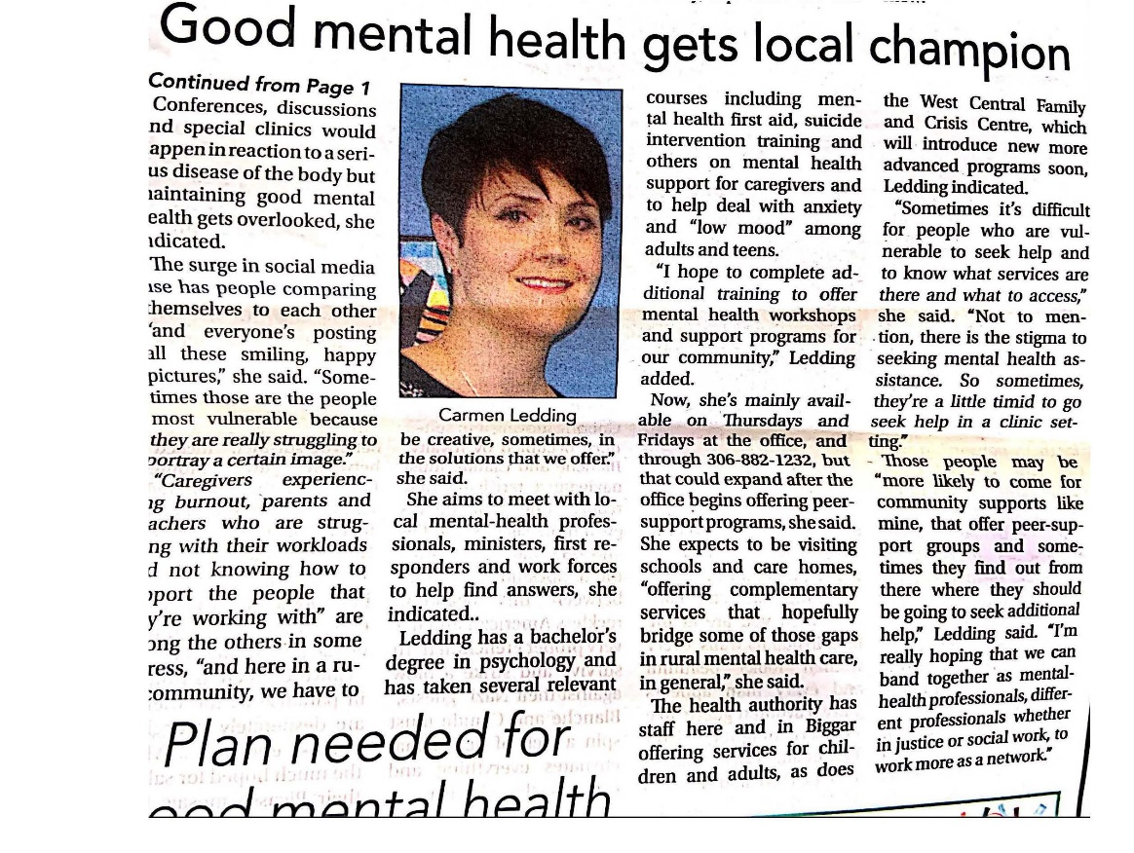
I have focused on training, as well as painting and decorating our new branch for the last few months. I have taken the Living Life to the Full Facilitator Training in Toronto, ASIST training, Mental Health First Aid Training, as well as the C.A.R.E. program in Regina.
I am happy to announce that the grand opening of Canadian Mental Health Association in Rosetown took place on Friday, May 10 to celebrate Mental Health Week. The event was advertised in the Rosetown Eagle newspaper, on local radio, digital signs in town, and I personally invited mental health practitioners from Saskatchewan Health Authority and Sunwest School Division to join me for coffee. The support has been overwhelming. During this time, I have identified two major initiatives for our branch.

- Develop and host an interagency network for Rosetown and District for mental health practitioners, School division, RCMP, ministerial association, Kindersley Mobile Crisis Unit, and other interested parties to meet quarterly to discuss local mental health initiatives. It is difficult sometimes for many different sectors to know who to contact in the face of mental health crises in a rural setting, and such a network is crucial in order to work in a supportive community with limited resources. I am partnering with Kindersley Interagency Network to develop this platform.

- Develop a support program for parents of children who suffer from mental health illness (to be labelled “behavioural challenges” to combat stigma). Local mental health workers and community members expressed a need for parents to have a support group which provides information on how to navigate the lengthy intake process, what to expect, and provide a supportive atmosphere for them to socialize in.

At this time, I am recruiting potential board members and volunteers, as I am the only employee of CMHA
Rosetown at present. I have been contacted to present LLTTF for youth in Kindersley, a community to the west
of Rosetown, within their schools in the fall. I hope to have more to report in the future, as I am breaking new ground in our community.

MELVILLE BRANCH
Tim Ziola, President

The Melville Branch of the CMHA has had a very busy year! Our new monthly meeting room has been very well used for our board meetings and monthly support group. Our support group meetings have been a success as we continue to get new people coming out. We are seeing professionals such as Doctors and Nurses encouraging patients (who may be struggling with mental health issues) to attend.
On May 10, 2018 (Mental Health Week) we held an evening Dessert Theatre featuring “The Reel Anti-Suppressants” from Regina. This was a HUGE success as our board was graciously thanked by everyone who attended, and we continue to receive positive comments!
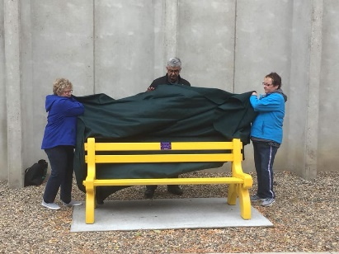
We had over 100 people attend for $15 each which included a CMHA Membership. Hopefully, most of them will continue with the membership from year to year!
In the fall just as school began, we presented the Melville Comprehensive High School with a Yellow Bench for mental health awareness. This project was very well received by the school, and we had an opportunity to speak about it at their first school assembly! Special thanks to Tait Construction and E&H Redi-Mix for donations of material and labor!
On November 3rd and 4th, 2018 we hosted a Mental Health First Aid course presented by our very own Kara Molnar (Melville board member and Registered Psychiatric Nurse). We applied for a grant from Painted Hand Casino and were approved 100%! This enabled us to offer the course for FREE! It was attended by 23 people who each received a certificate and training manual. The course is meant to increase awareness of mental health issues and assist participants in learning appropriate intervention strategies.
On December 9, 2018, our branch was asked to participate in “An Evening of Comfort, Support and Encouragement” presented by Matthews Funeral Home grief support team. The evening was for those who found the Christmas season difficult due to the loss of a loved one, illness, family difficulties or personal struggles. Two of our board members did readings appropriate to mental health and grief.
On August 9th, members of the CMHA Melville Branch volunteered at a pancake breakfast at Key Chevrolet Cadillac Buick GMC Inc. in celebration of their grand re-opening! A big thank-you to the Key Auto Group for donating back the proceeds of $337.65 to our local branch so we can continue to be a strong presence in our communities.
We once again attended the Melville Trade Show and Sale this April, promoting our branch and selling memberships. We displayed as much information from pamphlets to books. We also promoted our monthly support group! It was incredible the number of people who stopped by to talk and picked up brochures.
I must mention a special thanks once again to our entire board who continue to make all this happen. As well as the support from the Saskatchewan Branch of CMHA! We now have a full board of 11 people including two new directors this year.
Our AGM was held on Wednesday, April 3rd, 2019 and all positions were acclaimed for the upcoming year.
President – Tim Ziola
Vice President – Vicki Ottenbreit
Secretary/ Treasurer – Kelsey Karius
Board Members – Ruth Cooper, Micheal Halyk, Kara Molnar, Jordan Sinclair, Kim Unterschute, Lesia Baker and Erica Cherney

MOOSE JAW BRANCH
Donna Bowyer, Program Director

As I was looking at doing my Annual Report I was wondering what I would like to put into it this year. Once I started making jot notes I realized it has been a full year. I think the theme of this year is all about partnerships.

We starting by working with the Journey to Hope to bring Pricilla Lalonde to Moose Jaw from Alberta to present two workshops in Moose Jaw. The first being Little Cubs which is learning about intergenerational trauma and Indigenous children that can lead them to having thoughts of suicide or other mental health issues. We learned that the trauma that is experienced by children is not exclusive to Indigenous children. Although the cause may differ we need to be aware of the impact on all children. The other workshop she delivered was Walk with Me. This speaks to the Indigenous community after a suicide and the historical picture of Indigenous families, culture, and loss of traditional skills that would have been handed down from generation to generation but was interrupted for several generations. This was about understanding.

In May in honour of Mental Health Week we had our 3rd Annual Masquerade Ball, which was once again very successful in terms of fundraising but just as important, our fun ratio. These are becoming more successful each year because of the people that organize it, and recognize how important having good, healthy fun is to our mental health.

As this was our 100th year of CMHA we wanted to do something to honour the Anniversary and wanted to have it last past the end of 2018. In partnership with CMHA SK Division, and Journey to Hope, we contracted Nebulus Entertainment and Nicholas Kennink and had a song Darkest Hour written and produced, and 3 short multimedia videos: Heroes, Words, and Anniversary. After sending them to CMHA National, they decided to use them as well, and had the video’s subtitled in French and sent throughout the CMHA National family of Branches. Darkest Hour is a call to action for everyone to be the voice of those who may need someone to speak for them.

We once again partnered with Talk Today to provide safeTALK to our local WHL team, the Moose Jaw Warriors. We have had an ongoing partnership with the Warriors for a number of years and aside from the safeTALK we give ongoing support to their players, and staff. They did a fundraiser and we received $2500 from it.

Once again drumming has been spreading though other areas besides our members. We have been asked to take out drumming to Craik Library as well as several times throughout the year with students and staff at Palliser Poly Tech.

During the Bell Lets Talk campaign we partnered with 15 Wing to tour through their base command talking about stigma and breaking the bondage of stigma.

With our partnership with Journey to Hope we took a leading roll in Suicide Awareness Day (Sept 10), the Walk of Hope (Sept 22), National Survivors Day (Nov 17), and our second Hope Summit (Nov 3). We are very proud of the quality of presentations of people telling their story of hope and what helped them get through times of darkness. The presentations from the Hope Summit will be available on our Facebook page and also our website over the next few months. https://moosejaw.cmha.ca/

We also partnered with National to deliver Living Life to the Full to 15 Wing Military Family Resource Centre (MFRC). Although all preparation was done and advertising was completed they were not able to get enough registered.

Our Peer Support Program continues to thrive. We have three levels, One on One Peer Support, Come Together Peer Support Group, High functioning Autism Peer Support Group, and we have a Phone Peer Support Tree. These have become more important as over the last few months we have seen Mental Health Services make a decision to reduce the case load of their Community Health Nurses. This means that people that have been receiving services from the Community Health Nurses and Independent Living Coaches, and are doing well, will no longer be on their case loads. For some of our members this is a major loss and so we are providing a little additional support to some of those people. With changes on the In-patient unit we also have a couple of our Peer Supporters going up to the in-patient unit to provide activities or friendship to those hospitalized.
This is done on an informal basis.

We partnered with Prairie South School Division (PSSD), to provide MH presentations in schools, SafeTALK, and ASIST training. As PSSD and Holy Trinity School District introduced their Mental Health Curriculum into their high schools as an elective we became the teacher’s resource agency.

We have been having some discussion about what type of vocational program would best fit our members as the Mental Health Service/Thunder Creek Rehab. have discontinued the vocational program they were doing. We want to make sure that it meets the needs of the age populations that we have and where there would be a void where other agencies may not provide the service that meets the needs of our population. There are a number of agencies providing employment services but it is not working for all of our members. This will be something that we will be looking at more deeply in the 2019-2020 year.

I would like to thank all the partnerships we have had over the past year, both mentioned directly and the other many partnerships. I would also like to thank the volunteers that keep our agency, running both community volunteers and especially our peer support volunteers. Without them we could never do the things that we have been able to accomplish over the past year.

PRINCE ALBERT BRANCH
Doug Kinar, Executive Director

This year has been rewarding for our Branch in many ways. The programs continue to do very well. We had a total of 7823 distinct visits and served 5683 meals over the course of this year.

We have had several people who have transitioned into fulltime or part time jobs. The flexibility of the Vocation Program allows participants to utilize as they may need. Some have full time and or part time jobs, their involvement will reflect the amount of time they have, yet they still want to be involved. For others, participation is full time. Each participant understands their role as a team player; the importance and value their participation means to the overall operations of the Branch. There is a certain amount of pride when one can say, ``I`ve got to get to work`, ``I start work at…``. The work required to be done is not on a “make work” process to keep them occupied, rather it is an integral part of the operations of the Branch. Without their participation in the programs, the Branch would not function. Last year our participants worked a combined total of 14,656 hours.

We offer seven Vocation Program choices. Most programs are in house but the As Good As New store, Diner and BBQ require engaging the public in a meaningful manner. These programs provided a small amount of revenue but the main focus is to provide an opportunity for our participants to engage the general public as well as reduce the stigma of mental illnesses as our customers get to know our participants as people rather than as a marginalized group.

Our Diner program has been a great success! Our kitchen prepares nutritious menu items for the students at First Nations University. The Diner program will transport, set up a serving station and serve to the students, affordable lunch choices for $5.00. First Nations University is committed to continuing the service we provide by serving healthy, nutritious lunches to their students.

Our educational programs Art and Writing for Your Life are very well attended. They are once again celebrated with a month-long show at the Prince Albert Arts Centre. We hope to publish another anthology of their combined writings in the near future.

Our partnership with Correctional Services Canada has also been a great success. In fact, our pen participants have earned their way into full time positions within our agency. Most of the renovations would not have occurred without their help.

New Starts! We are hoping to start a new vocational program processing firewood for sale in our region. The participants are interested, the board appreciates and supports the idea and the public we have polled seems to support the idea. We have begun the process of gathering wood and splitting and ordering bags in order to sell. We will sell small bags in our As Good As New store, advertise on social media, as well as signage posted at the work site. This is a great opportunity to work outside, get some fresh air, exercise our lungs and stiff muscles. It is a seasonal job and weather permitting. Again, while the revenue is welcomed, the social, physical and mental well-being is our focus. We will keep you posted.

Our community kitchen continues to grow as we add new participants from our housing units.

Our new six unit supported living apartment complex is now open. This brings our total units to 22. We are excited to continue pursuing housing for our people.

Our board voted unanimously to name the building Joni’s Place in honour of Joni Hladun. Joni Hladun was a lifetime board member of the Canadian Mental Health Association, Prince Albert Branch. When I began as Executive Director in 2004, Joni was a board member already. Since my beginning, for 14 years Joni served on the board of directors with distinction, compassion, commitment and steadfast support. She was honored with a life-time membership as an actively serving board member.

Joni loved to garden, she was extremely creative and hosted many Christmas board meetings in her character home in the West Hill of Prince Albert. Joni made everyone feel welcomed. Joni was always supportive when it came to be benefitting the people who attend the branch and the role CMHA PA Branch played in the Prince Albert community.

Before Joni’s passing, I was able to share with her the board’s decision to honour her dedication and contributions to our agency and the Prince Albert community. Her presence on our board of directors has been missed.

As stated earlier, it has been a rewarding year, but also a year of losses. Sadly, we said goodbye to CMHA staff and participants and health region members that passed. They are kept alive through our conversations and memories.

We continue to keep alive our traditions at the Nest. All holidays are recognized followed with a special meal that is always free and open to inviting a friend or family to dine with us. Halloween and Valentines are always a lot of fun at the Branch, followed with dances, costumes, prizes and our most anticipated event the `Chili Cook Off during our lunch for Valentine’s Day.

Just a note regarding our annual chili cook off. I lost to the Thug Muffins’ vegetarian chili by a mere two votes. Sigh. I am confident I will regain my crown next year. Not sure we can legally call their concoction ``chili`` since there was no meat in it. Not one to back down from a challenge, onwards and upwards, I have a year to perfect my next entry!
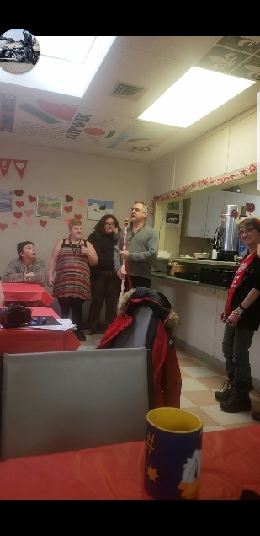
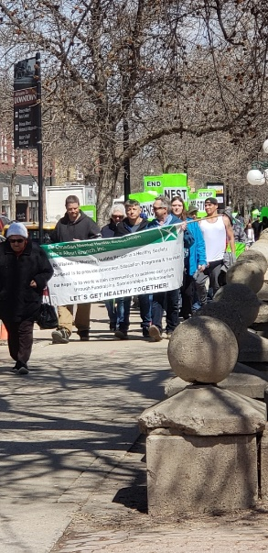
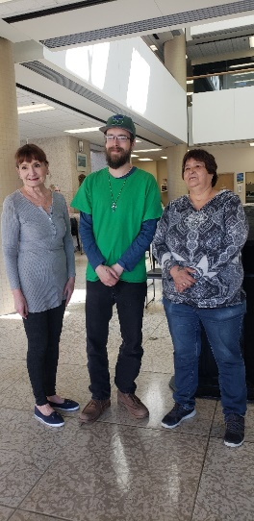
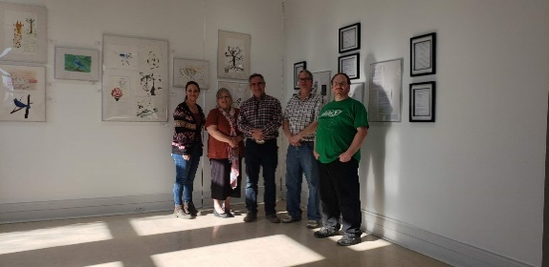

REGINA BRANCH
Leroy Berndt, Executive Director

CMHA Regina Branch continues to operate Pre-Vocational and Vocational Programs and are proud to have them meet the needs of over 12,500 members in Regina who are living with a mental illness.

Vocational Program
At CMHA Regina Branch we have many members who work in 5 different areas that gives them an idea as to the skills they will need to work in the open labour market.

Most locations that provide vocational assistance and support, work from a model called Supported Employment. This model’s main purpose is, all people no matter their ability or disability should be able to feel the pride and feelings of contributing that we all do when we work. It and many other models have discovered the most effective step is get people in to the work environment as soon as they indicate that they would like to work.

The kitchen employs seven members. This past year, thanks to Punchline Comedy Night, we were able to get more members Food Safe trained and certified. A group called Munch Catering was able to train our members over two days. We served over 14,000 meals made in our kitchen. It’s wonderful seeing how good these folks felt when they were able to get their certificate. We are planning to train more of our members this coming year.
The front desk at the Member’s drop-in centre employs about ten people and members also work in our Canteen.

The Janitorial program at the branch employs twelve members who clean our own building and four more members are out in the community doing house cleaning. We have seventeen house cleaning customers and two business customers.
Members are also helped with resume writing.

Pre-Vocational Program
There were a lot of new faces welcomed through our doors this last year. Our population continues to grow as people from all walks of life are expressing interest in utilizing our services or wishing to get involved by volunteering or to support the Regina Branch in remarkable ways. Many people stop in at a critical point in their lives; having the courage to seek support or in search of guidance to address their complex psycho-social needs or to navigate the system (struggling to access mental health and addictions supports, secure housing and food, or advocacy, etc.). Other times people are just looking to connect with others, socialize in a non-judgmental environment, and find a place to get involved, or they may be interested in becoming more active and engaged in a community. Our staff have been phenomenal in assisting to “meet people where they are at”. In other words, treating all people with respect and dignity when they come through our doors and from there our program goal is to support people to thrive in their own recovery journey.

In 2018 an average of 26 new applications for membership were completed each month and this is a 33% increase from last year. It has been a challenge to track the increasing number of drop- in visitors and email/phone contacts for support that we address each day as often these occur during the noon meal which is the busiest time for the drop-in center. We have encountered Regina’s crystal meth crisis too and are working to ensure everyone’s safety and well-being while trying to support those individuals entrenched in this epidemic.

The Pre-Vocational program promotes inclusion, helps strengthen peoples’ capacity, and serves to reduce barriers. The impact of our program is demonstrated in the annual client survey that sheds light on the value and benefits of our programs and services from those who know us the best. In 2018:
- 81% of Members surveyed indicated that CMHA services/programs helped keep them out of the hospital.
- 81% identified that CMHA helped them gain knowledge and skills on how to make healthy choices.
- 87.5% shared that Club activities gave them a sense of belonging in the community.

It is significant to note that the drop-in center - aka “the Members Club” - a hub of ongoing peer interaction and engagement, was still rated on the annual member survey as the most important service to our clients, with the lunch program coming in second.

In addition, this last year our program staff, practicum students, and volunteers offered an increased number of activities in three measurable categories (in house, in the community, and educational/wellness sessions). The monthly activity calendar, which can be viewed online, illustrates the array these activities, with an average of 200 structured activities offered each month (up 18.5% from last year). Program stats indicate that participation increased by 31% from last year which equates to members being involved on average of 2163 times each month.

The members survey ranked activity importance as follows: monthly birthday parties, 1-1 time with staff, coffee groups, YMCA access, bingos, daytrips, community outings, music group, Wi-Fi access, Lawson field house, crafts, dances, camp, open art studio, and yoga, etc.

We are so thankful to the many dedicated supports and our fundraiser partnerships for their contributions to enhancing our facility. It has been a fantastic year of much generosity from our community partners and the volunteers who truly help make it possible to provide the extras for our Members throughout the year. For example: St. Georges continues to grace us with a special meal one Saturday a month and fresh fruit every Sunday, along with new winter boots, socks, other winter attire to hand out to those in need.

St. Martin’s Crafters’ provided a Chinese Buffet on Christmas Eve and money for additional program supplies and outings.

The East View Rotarians for gifts of warmth, the Inner Wheel group for the St. Patrick tea, Regina Downtown Business Improvement District raised money for our program, Crocus and Ivy for the New Year’s Eve party,

Punchline Comedy group for Club furniture, pool table, and the Indigenous Drums. Over the Christmas season many other community groups have donated to support our members. It is this amazing generosity and caring people who which really can make the difference in someone’s life and promote positive mental health for all.

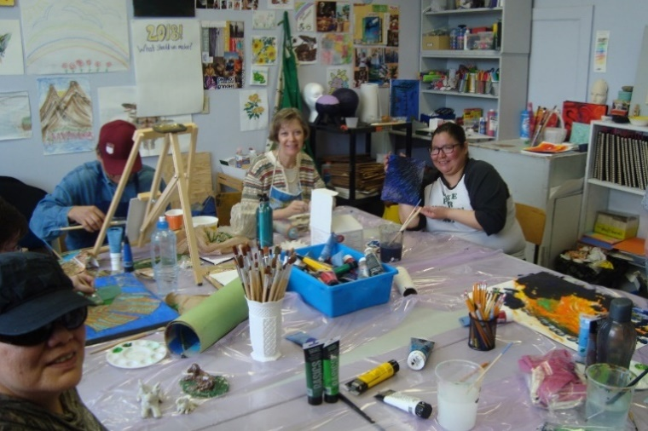
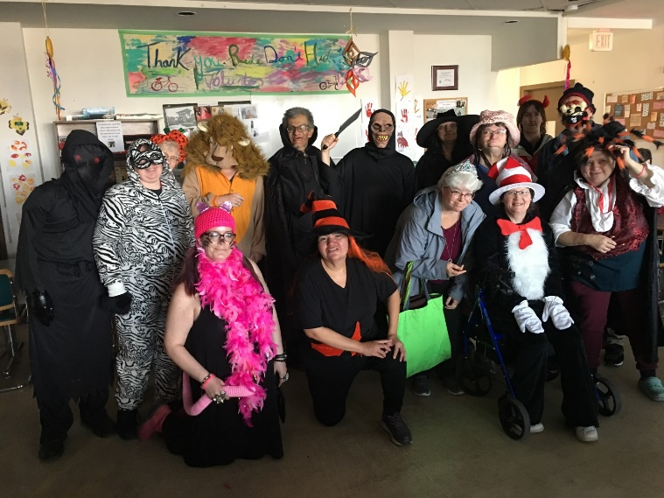
Members in the Open Art Studio (bottom) and the Halloween function at the Branch.

The community engagement area continues to be extremely busy with numerous presentations to elementary, high-school, post- secondary institutions, as well as workplaces, service groups and various other organizations.

Thanks to the generous fundraising event “Punchline Comedy Night” (PLCN) we were able to offer free safeTALK training sessions to various university areas as well as the community sector this past year.
This past year we were also able to have two staff trained as facilitators of “The ASK Program” which is Assessing Suicide in Kids (those working with children 14 years of age). We look forward to assisting the teachers, community and health care professionals working with children of this age to gain a better understanding and alertness to young children who may be exhibiting signs of suicide.

The PLCN fundraiser has had such an impact on our branch and in the community – a few additional things that this past year’s event has done for us are; provided the members club area with brand new medical grade club chairs, a pool table, TV, Wii fit, new board games, and new tables and chairs for our eating area. One of the most special opportunities came when we were able to hire one of our own members to make 8 traditional drums so we could start a drumming circle for our members. The member ordered the buffalo skin, drum rings and ties and made them in his kitchen. The impact to him was phenomenal as he took much pride in being able to give back to the branch which had given him so much over the years, in addition to allowing him to connect spiritually which was very important to him. He now leads a drumming circle twice a month for anyone who wants to participate. The drums, while significant to our Indigenous members, are also another tool in the toolbox for all our members as the beating of a drum is seen therapeutically to assist people with anxiety.
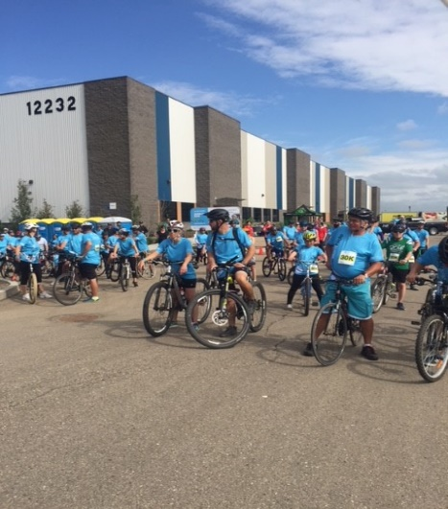
Our Ride Don’t Hide event this past year was another phenomenal success where we were able to join a community together to help decrease the stigma surrounding mental illness while also helping them recognize the importance of taking care of their mental health and mental well-being. This event would not be as successful if it weren’t for the wonderful sponsors, participants, fundraisers and of course the 60 plus volunteers. The Co-operators have been our platinum sponsor since our very first ride in 2013. With only one year (2014) where we didn’t have the ride, this event has seen both growth in numbers as well as in fundraising dollars.

We have also had numerous other smaller, but not less important, fundraising opportunities this past year such as Crocus & Ivy – Here Comes the Sun Fashion Show; Hope, Honour, Heroes Walk; More Joy Regina, Rotary Club of Regina Eastview Valentines Gala; Jam Jar (The Giving Back Team) just to name a few.

We have had a very busy year but one full of support, generosity and understanding. We look forward to building our relationships in the community and doing our part to educate and reduce the stigma.

Our new pool table thanks to Punchline Comedy Night!

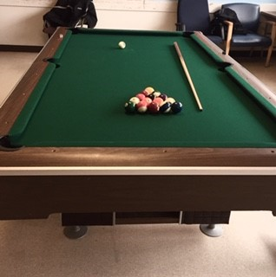

A special word of thanks to all our donors, sponsor and funders who have made much possible this past year.
Please visit our website at cmharegina.com and like or follow us on twitter and Facebook to stay up to date on the great thigs we are doing in Regina.

SASKATOON BRANCH
Faith Bodnar, Executive Director

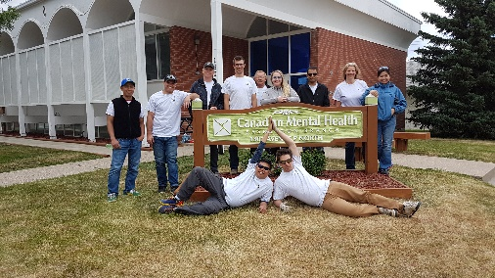
For CMHA Saskatoon, 2018/19 has been a year of new directions and laying the foundation for future growth and development. Guided by the work of a great staff and board of directors, we are reaching out into the community, asking what is needed of us, what the gaps in services are and how can we be part of building more inclusive and supportive lives for people who experience mental health issues. We remain committed to our federation at a local, provincial and national level, knowing that we change lives and build resilient communities. We benefit directly from the work of Division as it leads the development of critical research and sound social policy on mental health. The recent increase in the earnings exemption for those receiving SAID benefits reflects years of Division working with the government so that recipients can keep more of the income they earn. This significant development will increase the quality of life of those on benefits who can work. Our thanks to Division for their leadership and advocacy.

Board and staff members from CMHA Saskatoon joined colleagues from across the country in Montreal, to celebrate the 100th Anniversary CMHA National. The sessions and workshops showcasing innovation and collaboration were enlightening and inspiring, connecting us from coast to coast to coast. We remain an essential, first point of contact for people in Saskatoon and area, regarding a whole range of mental health issues. Whether people seek support, need advice or have questions about how to navigate services, we are there to help. We also delivered a full range of workshops and training events to over 4000 people, who are part of sports clubs, workplaces, government offices and community organizations. With our vocational programs, we provide person centred, holistic support that focuses on helping people access community based, employment options, while also supporting them to develop the capacities and skills to live full lives. Whether people are attending our Vocational Life Skills program, receiving services from our Vocational Counsellors, or needing more general Counselling, we work as an integrated team for as long as people require. We’ve streamlined our intake process to serve people more effectively and reduce wait times, but we recognize that there is a growing unmet need in the community.

CMHA Saskatoon developed a new 3-year Strategic Plan this past year that guides us as we develop an
Indigenous lens in all our programs and services. We have hired an Indigenous consultant to help us
become a culturally competent agency and implement the recommendations from the Truth and
Reconciliation Commission. We also identified 5 other key Strategic Priorities including:

- Education and Awareness – affirmed as a core priority to reduce stigma and increase
understanding through new marketing and communication tools and campaigns.
- Program Development – canvassing the community so we can better understand what is needed.
- Organizational Health – maintain a healthy, open, collaborative organization at all levels.
- Revenue Development – growing and diversifying our revenue streams.
- Support and Advocacy – provide support, navigation and advocacy so that people can access
the community mental health supports they need.

As part of our commitment to serve the community, CMHA Saskatoon is exploring how we support
children and youth. Currently our R.I S.E. program (Resilience, Information, Support and Empathy) is
only available at Bedford Road Collegiate. We anticipate we will expand to other high schools in the
upcoming year and are open to other opportunities that support youth and children.

This year we launched 2 new initiatives. The RUH Foundation approved funding for Connect Up, to
support people with mental illness to access community based, inclusive social and recreation programs.
We look forward to working with community programs to develop their capacity to include people with
mental illness. In addition to the support groups we already have – Depression, Anxiety, Post Traumatic
Stress, Writers and Quilters groups- we are starting a Family Support Group in conjunction with the
Mental Health and Addictions unit of the Saskatchewan Health Authority.

At CMHA we seek out opportunities to work collaboratively with other community organizations,
stakeholders and leaders. Saskatoon is changing and growing, and we remain rooted in leading the development of innovative services and programs.

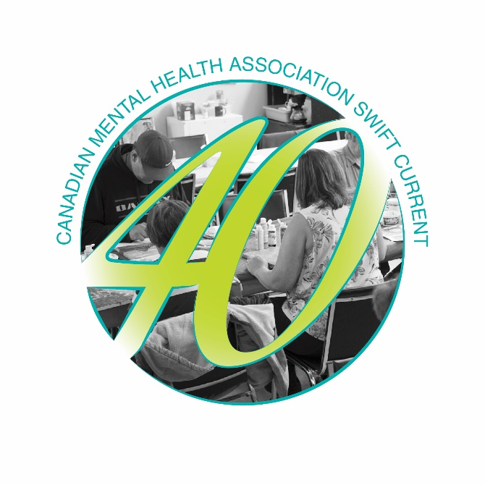
SWIFT CURRENT BRANCH
Jaqueline Williams, Executive Director

Our Swift Current branch celebrated our 40th Anniversary this past summer. We opened our doors on August 8, 1978 and started out as the Alfred Cooper Club. There have been many changes to our organization over those 40 years, but support for individuals living well with a mental health diagnosis was always our purpose.
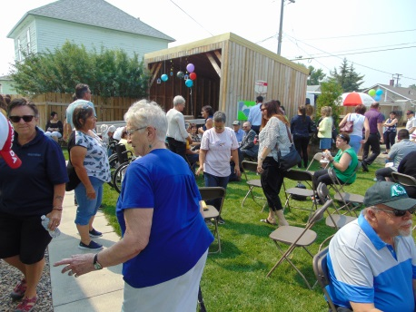
Our Clubhouse was open to the community and we celebrated with a BBQ and delicious cupcakes. Members, Staff and Board all participated in tours of our facility.

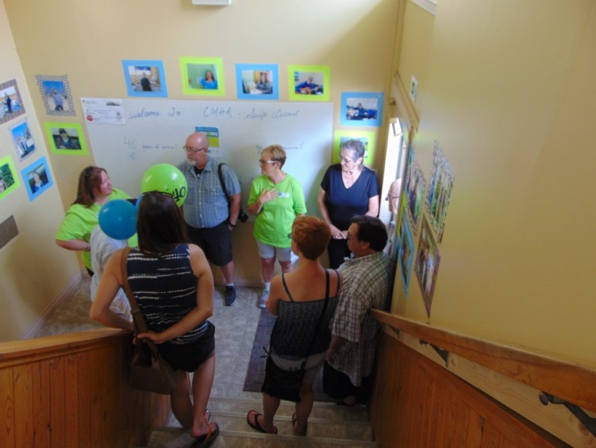
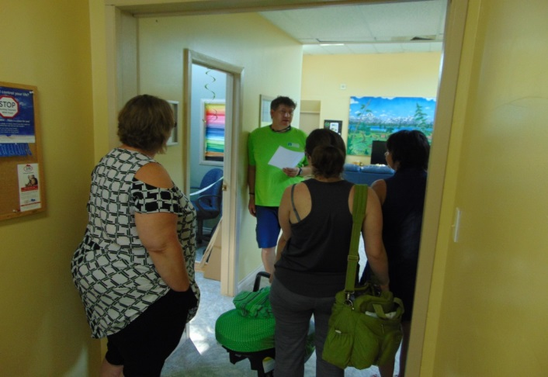
It also allowed us the opportunity to start our focus on a new facility by highlighting the tremendous support given to us by the Durward Seafoot Estate.
This gave us the opportunity to share a little bit about who we are and what we do.

This fall we were fortunate to receive a grant to support our Peer Support Leader program. This has meant an increase in hours with programming occurring some evenings and one day on the weekend.
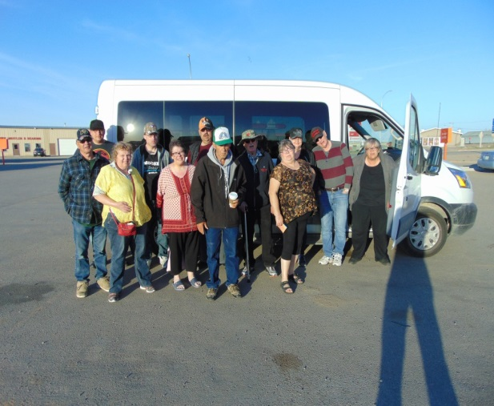
The Members work with the Peer Support Leader and have their own fund raiser. The proceeds from their Harvest Wreath Raffle enable them to get out of Swift Current and see more of what this province has to offer.
December 11th was a day for the history books. We had submitted an essay to the IA Financial contest “What would you do with $125,000?” We were notified in November that we were a finalist and immediately started an online campaign to secure votes. This was amazing news because everyone in the top 10 would receive $10,000. The top 3 prizes were 1st $125,000 and 2nd and 3rd for $50,000.
IA Financial told us they were going to all the finalists to announce live who the winners were. They were bringing media with them and we were sworn to secrecy. Dec. 11th was also our members Christmas party. We had a full day of events planned in addition to the announcement. Finally, the time came and Catherine unrolled the banner...

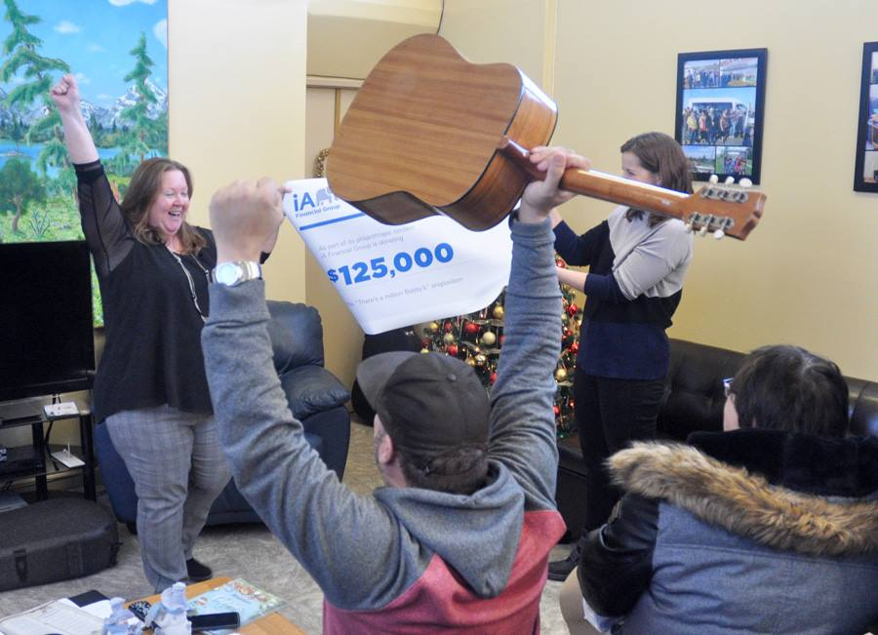
Because of this prize we will now have a part time vocational program for 2 years as well as money towards our new building.
We are currently looking to hire a new person, further expanding our programming. The Vocational Program should be up and running by May 2019 and has secure funding until April 2021.

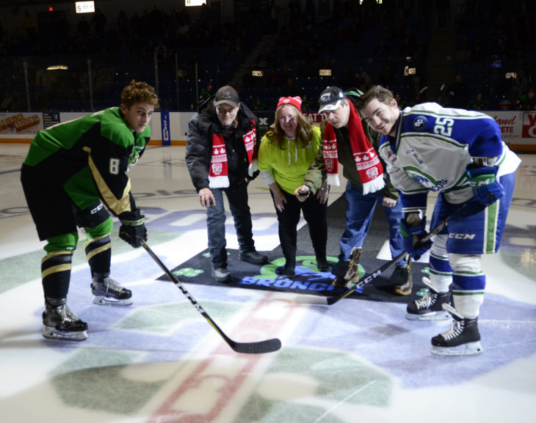
February always brings about our WHL event with the Swift Current Broncos.
There is a lot of community support for this team and we are happy to partner with them.
Thanks to Donna Bowyer for providing Talk Today to our team.

Our meal program – cold breakfast and hot lunch served 7027 meals in 2018. Members actively take a lead role in the programming. Helen, our cook appreciates the “many hands make light work” approach in the kitchen and members assist her daily.

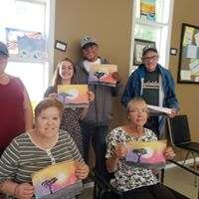
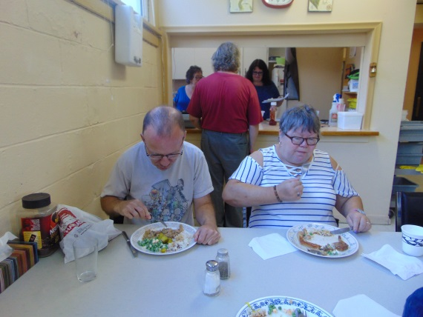

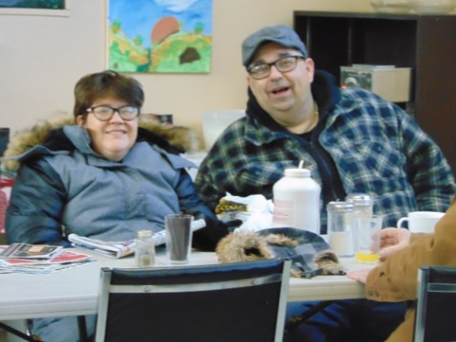
Members and community supporters make our social, recreational and education programming a success. Our Program Coordinator, Sarah, has really stepped up the programs being offered at the Clubhouse and our participation stats have really risen. We are seeing a lot of active participation and volunteering amongst our members.

WEYBURN BRANCH
Tasha Collins, Program Director

CMHA Weyburn is grateful for the funding we receive from our partners including the Saskatchewan Health Authority, United Way, Community Initiatives Fund, Sask Lotteries, Sask Parks and Recreation, as well as the City of Weyburn. We are also truly thankful for the support we receive from our community through donations, attendance at events, hiring us for odds jobs, or assistance in raising the profile of mental health in our community.

The CMHA Weyburn branch provides variety of programming that is open to everyone in our community whether you live with an illness or struggle with your mental health from time to time. This past year we have seen our services improve and grow.

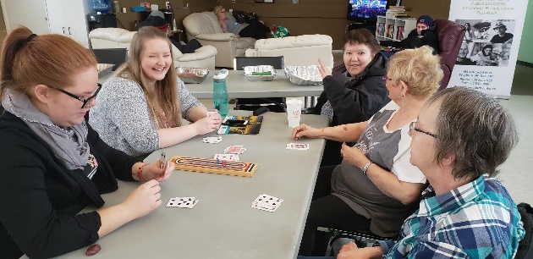
Our social and recreation programs continue to promote positive interactions and build confidence; some of these activities include tours, bowling, swimming, arts/crafts, billiards, movies, skating, bingo, library visits, crib games and tournaments, day trips, dining out, as well as visits to the Humane Society
Intense Cribbage game

CMHA Weyburn has visited different groups, schools and agencies to provide information on the services and programs offered within our centre and presentations on the topics of suicide and the difference between mental health and mental illness.
This year we were able to continue offering quality skill building programming to our consumers which included Writer’s Group, Art Program, and Sewing. We were also able to provide Life skills/Wellness programming with the support of Sask Health Authority Staff.
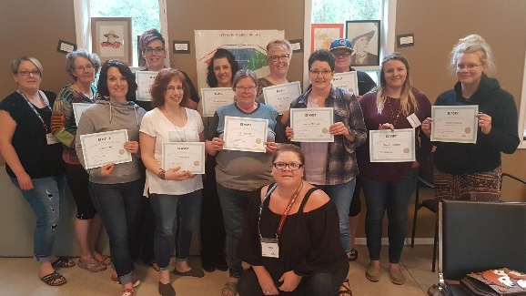
We hosted two safeTALK (Suicide Alertness for Everyone) workshops as well as partnered with Sask Health Authority staff to provide two workshops an ASIST – Applied Suicide Intervention Skills Training workshop and an ASIST Tune up workshop.
This past year we have had consistent evening programming in the form of support groups, self-help or community activities as we have had both interest and volunteers. This year we were able to offer the following evening programs:
ASIST trained certified participants.

The Compassionate Friends – Meets the 2nd Monday monthly – This is a support group for parents who have lost a child. It offers friendship, understanding, grief education and HOPE for the future to all parents who have experienced the death of a child at any age, from any cause.
Peer Support – Meets Wednesdays at 7pm – Facilitated by community volunteer trained in Peer Support, this program promotes mental health support through lived experience. Provides support, recovery, hope and through conversation and discussion
Arts & Crafts Night – 2nd & 4th Thursday every month - Adult community program, open to anyone who would like to participate. At this time there is no cost to attend, however we ask that participants register 7 days prior to class.
March Movie Nights – March 5th, 19th, and 26th 2019 – In partnership with Weyburn Credit Union. Select movies played, open to the community
Our vocational programs continue to operate, these include our work crew (offering snow removal, lawn mowing, raking, refuse hauling, cleaning services, and small moves), as well as our vocational meal program (providing homemade meals for those attending the centre, learning about meal planning, preparing, and grocery shopping continue).
We volunteer within the community where and when we can, we participate with the Adopt a Planter program with the City of Weyburn, as well as work with Salvation Army by providing refuse hauling for them.
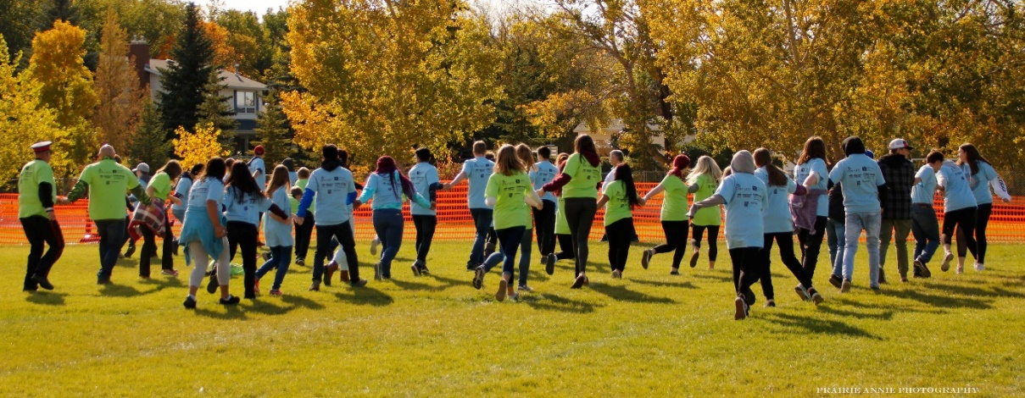
CMHA Weyburn hosted many events throughout the year, during mental health week we held our Annual Mayor’s Luncheon, Semi-Colon event, Youth Theatre Performances, and used book sale. We hosted other events to promote community engagement; which included our Annual Trade Show and gift wrapping in December. This past year we held an event called Breaking Records/Breaking Stigma; where we tried to break the world record for Largest Human Foosball Game, we may not have met our goal of breaking the world record, but we were successful in breaking down stigma with a clear message from our guest speakers to over 800 students to be open and talk about their mental health as well as seek help if they are struggling.
We continue to partner with another local agency to host Community Connections Meetings where those who attend learn from other service providers what programs are available in our community and surrounding area. CMHA Weyburn is currently working on putting together a community resource booklet for those looking for services.
Breaking Records/Breaking Stigma – Human Foosball Game
Through funding from Community Initiatives Fund we were able to run our Youth Theatre Program again this year, this program focuses on youth between the ages of 9 and 16, and allows youth to explore their creative side.

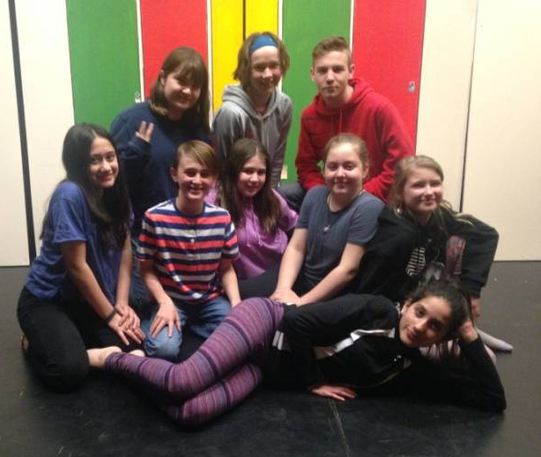
The theatre group encourages youth to learn, engage, and become active. It also allows them to grow, mature and become leaders through positive programming. The objective within the youth programming is to foster self-esteem, confidence, inclusion, and leadership.
Cast of Home Sweet Canflax May 2018
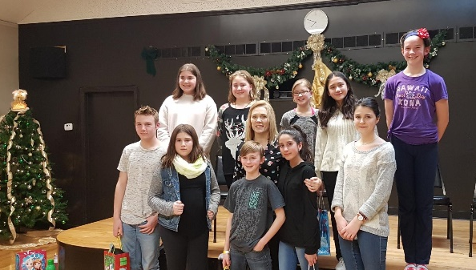
In the fall the theatre group participants work on specific skill building like improvisation or monologues, and then perform at CMHA Weyburn’s Christmas Party. Starting in January the group works together to build a play from the ground up and perform it during Mental Health Week in May.

The CMHA Weyburn Branch works hard to maintain quality programs and services for our community members. We are always striving to introduce new programs and mental health initiatives within our community as well as increase our capacity to engage others in conversation about mental health.
Christmas Party Youth Performance

Funding is something we have struggled with for years. Without consistent permanent funding, we have seen turnover in staff as well as programming. One of our ongoing goals is to secure permanent funding for a third staff at our branch. We have been lucky in the past few years to have received funding from CIF to continue with our very successful Youth Theatre Program, however those funds are not guaranteed. Our hope is to acquire consistent permanent funding to aid in staffing so our branch is able to continue growing and prospering with community specific programs and services for many years to come.

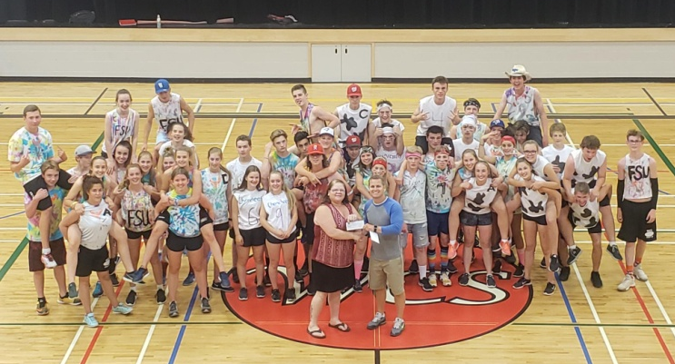

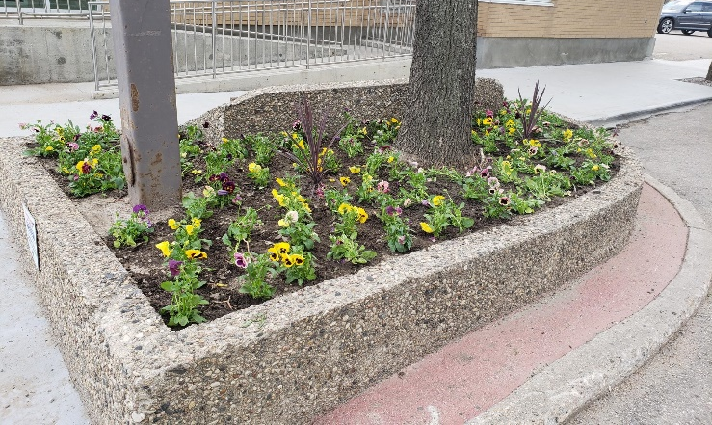
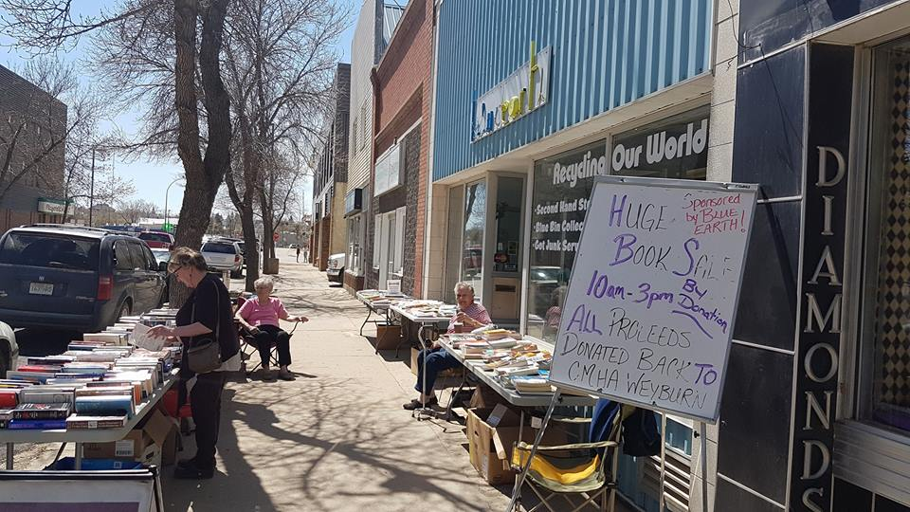
Weyburn Comp -Tchoukball Tourny

RESOURCE DEVELOPMENT
CMHA is dedicated to supporting and promoting the rights of persons with mental illness to maximize their full potential through education, advocacy, programs, and services. These programs and services provide a stabilizing support for people affected by mental illness, reducing their dependence on costly alternatives, such as hospitalization or institutionalization. The work of CMHA provides a cornerstone for a healthier community.

As a charitable, non-profit association, CMHA is dependent upon the goodwill and support of the community. Fundraising and “friend” raising initiatives like the Cash Calendar lottery ensure that vital programs in support of people affected by mental illness continue to provide for their needs.

Cash Calendar Lottery
This project has not only proven to be a very good fundraiser for the Association, but has also become a very successful public awareness tool, thanks to the dedication and hard work of the Call Centre employees. The calendar is unique as it not only displays the artwork of people who use our services, but of people whose artwork has been chosen through our yearly “artwork call,” which has in turn brought to light the magnificent artistic talents of many members of our communities. The calendar also showcases quotes from the artists about how their artistic talent supports their mental health. Many of our members are gifted with talents and skills left dormant due to financial and social restraints. The calendar has given them the opportunity to develop their artistic talents, to enhance social interaction and physical skills, and to realize some monetary gain through the use of their artwork.

Bingo

The Canadian Mental Health Association (Saskatchewan Division) continues to see a modest income from the proceeds of bingo generated at the Centennial Bingo Hall. Due to the dedicated group of volunteers who run the bingo for CMHA, very little staff time needs to be devoted to the bingo operation. The Board and staff of CMHA Saskatchewan Division extend their sincere appreciation to these individuals. We couldn’t do it without you!

Direct Mail

Public education goes hand-in-hand with all fundraising initiatives. People give to organizations they “know” or have heard about and with which they have a connection. For this reason, public education and awareness is absolutely necessary for the success of our direct mail campaigns. They not only raise funds for the Association, but they also continue to provide awareness and public education, which helps to reduce the stigma of mental illness in the
community.
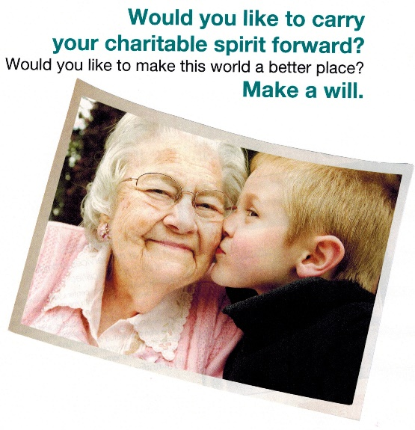

Planned Giving

CMHA Saskatchewan Division continues to expand our efforts in the area of planned giving. Planned gifts are dedicated in the present but realized in the future through estate plans. It is a way to carry your legacy forward. Through education and stewardship activities, CMHA Saskatchewan Division is encouraging individuals to think to the future.

30

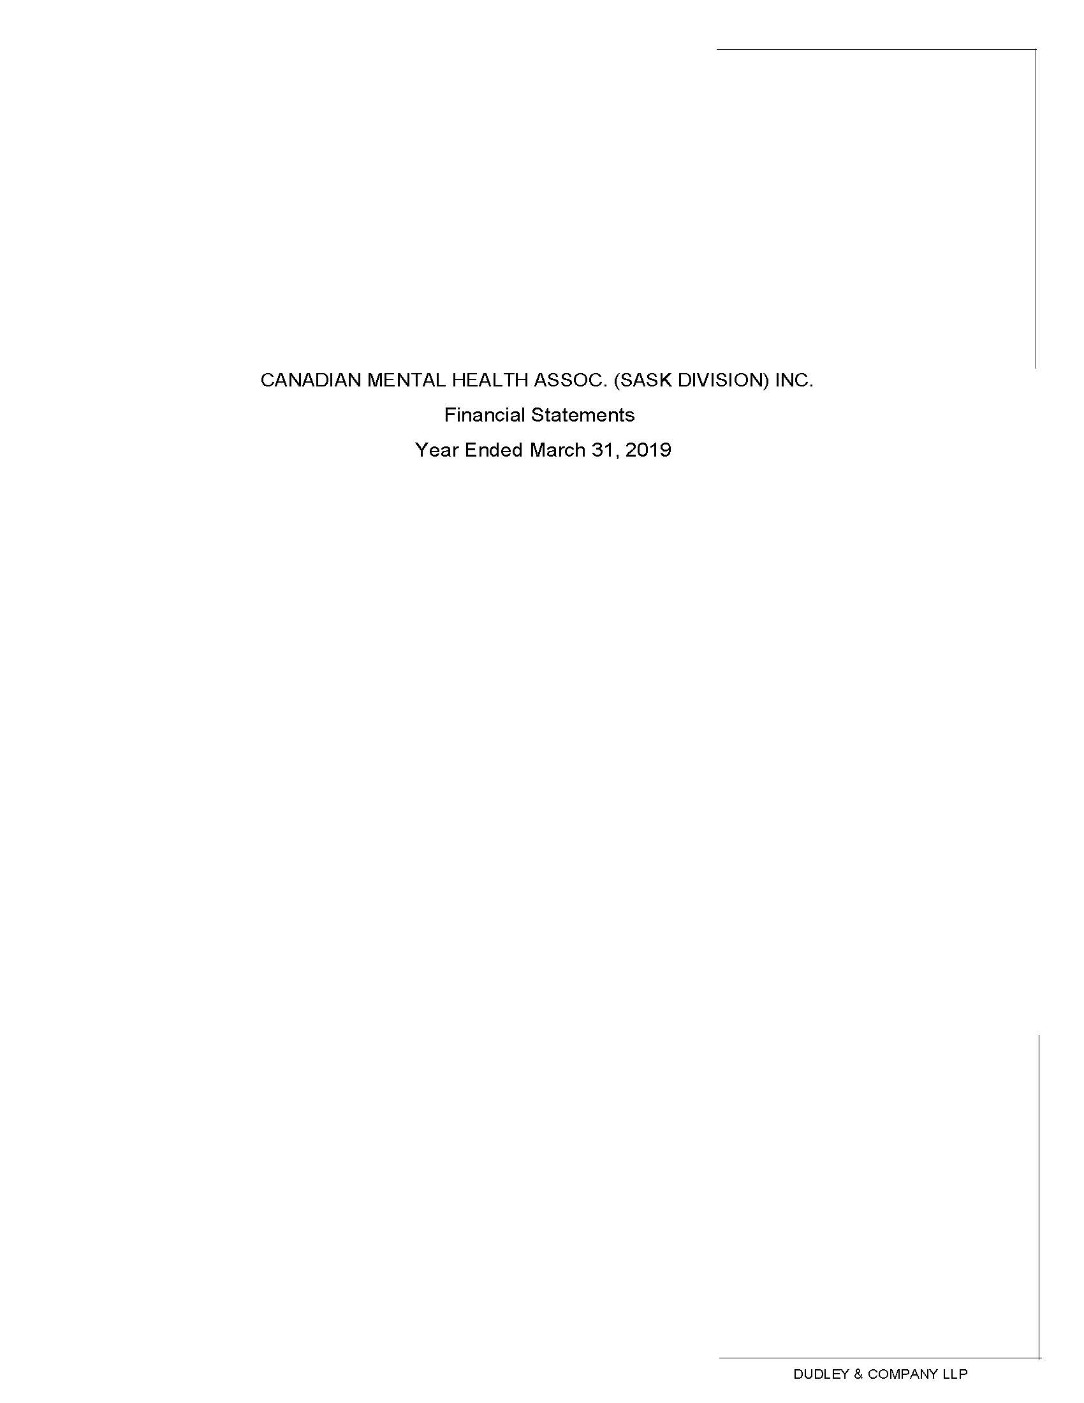

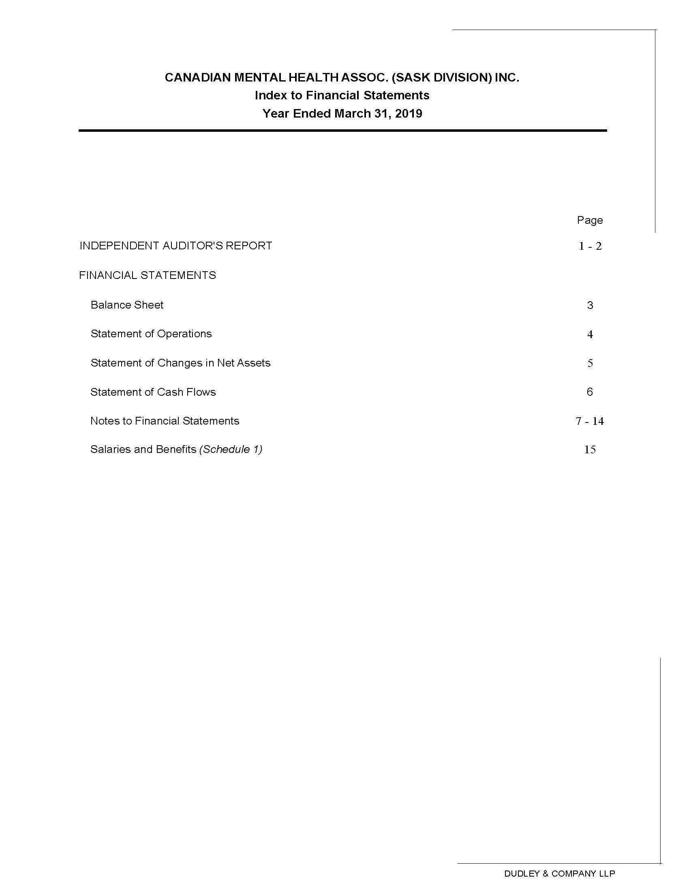

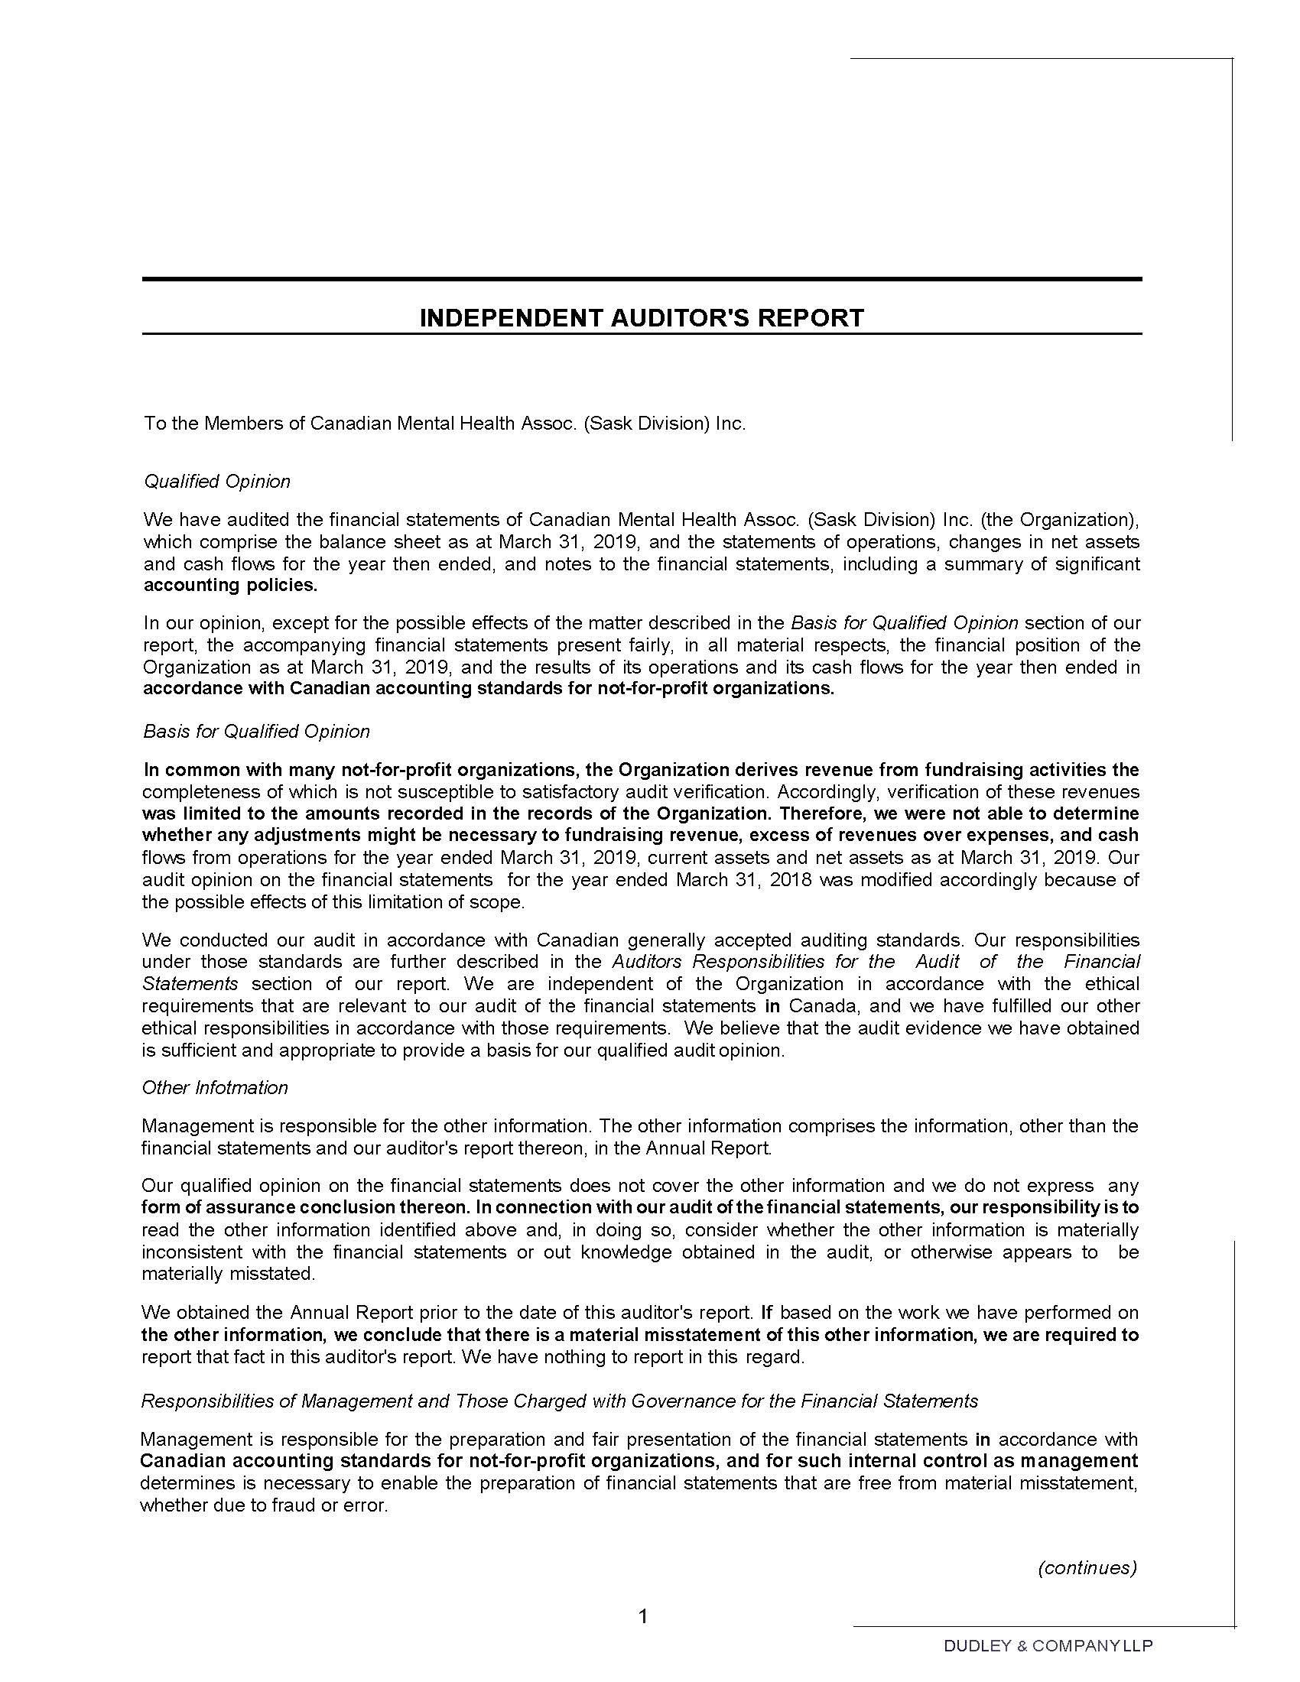

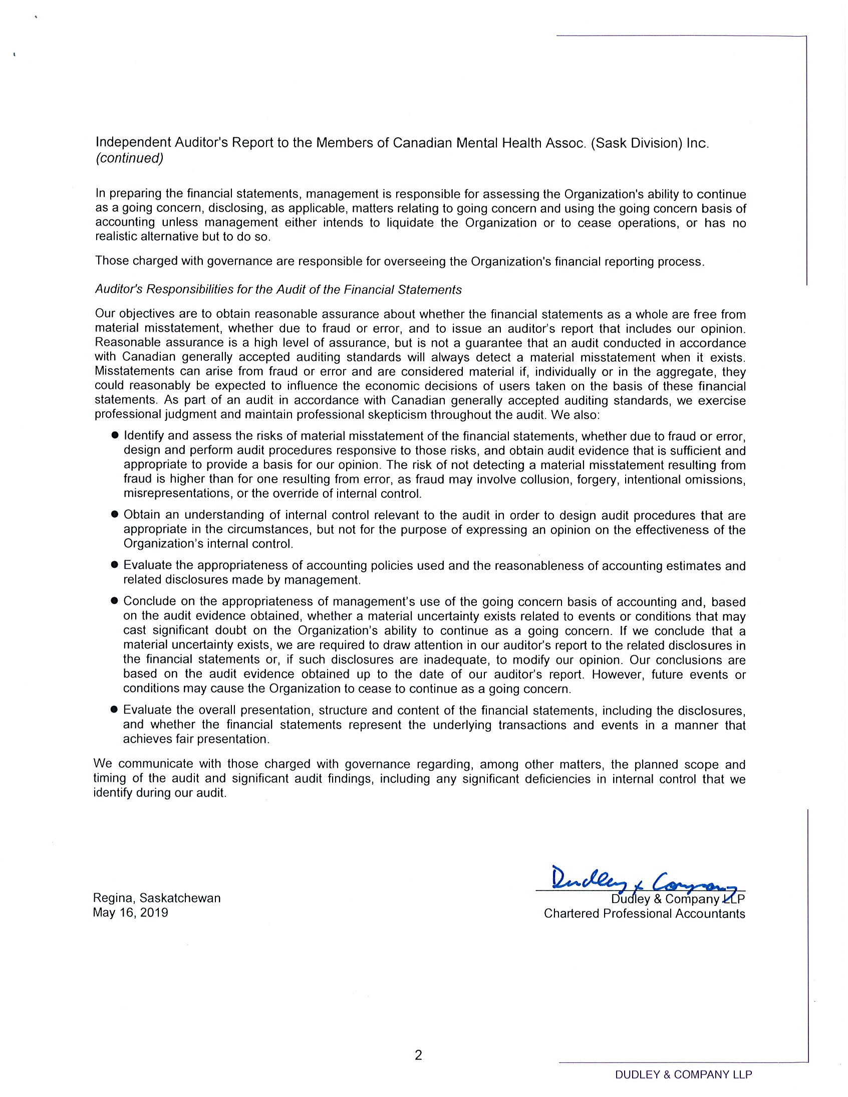

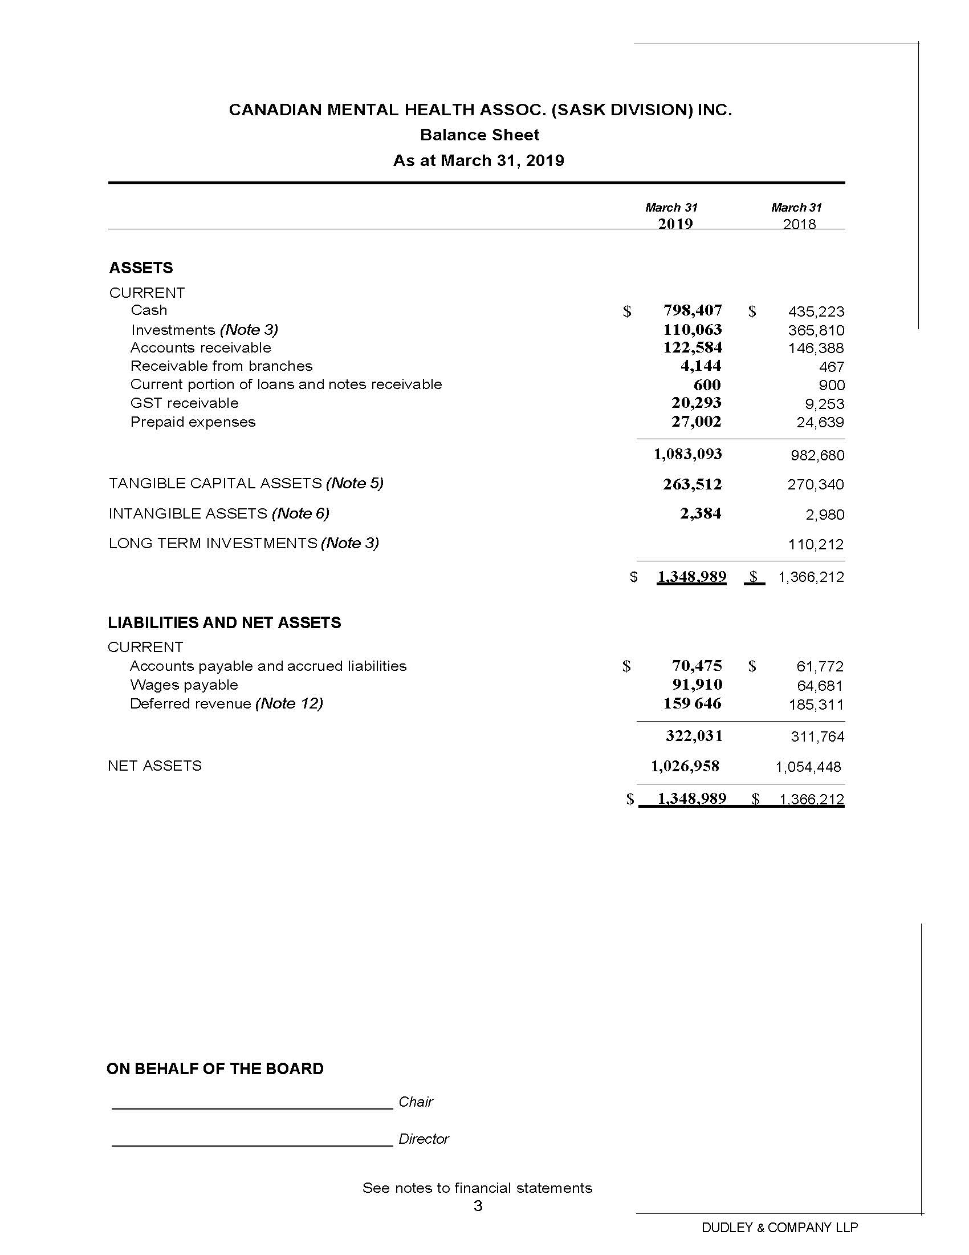

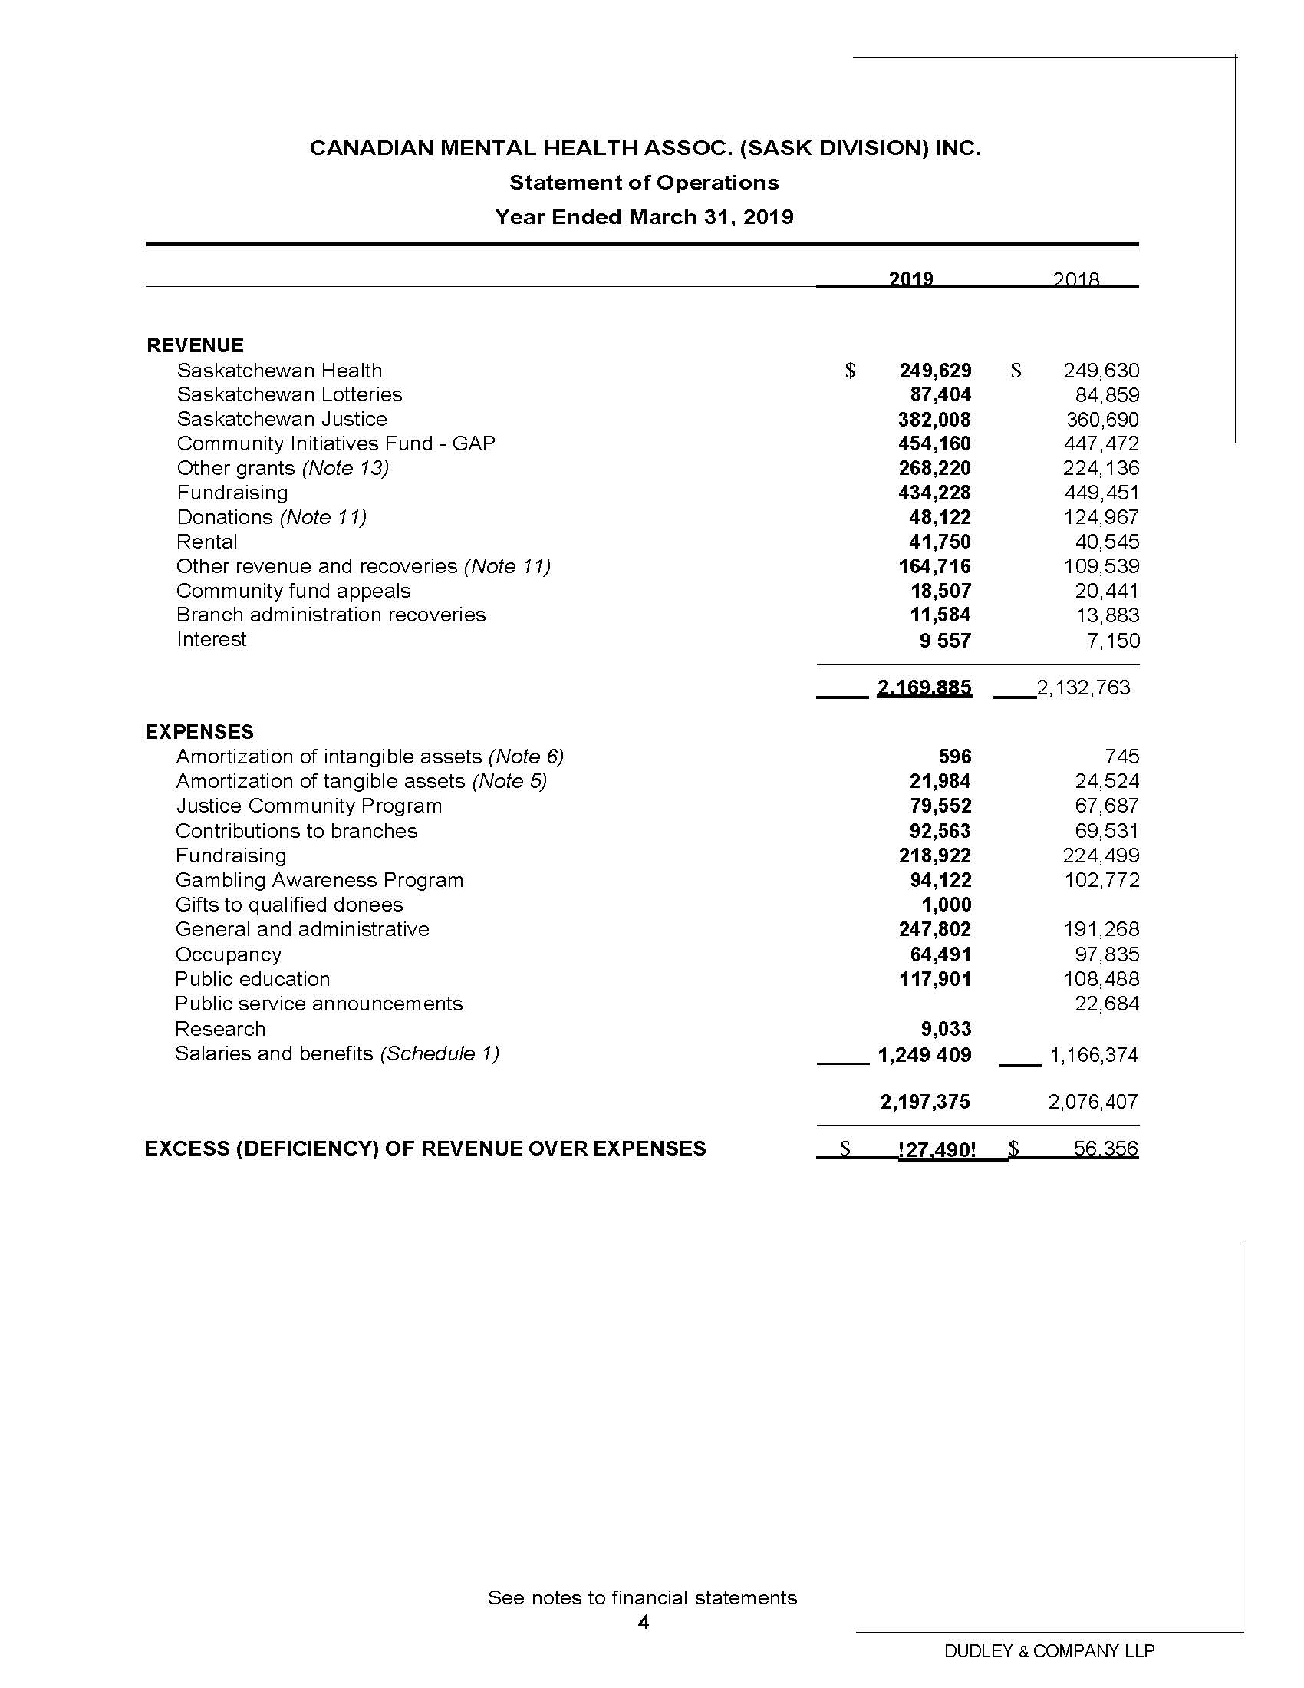

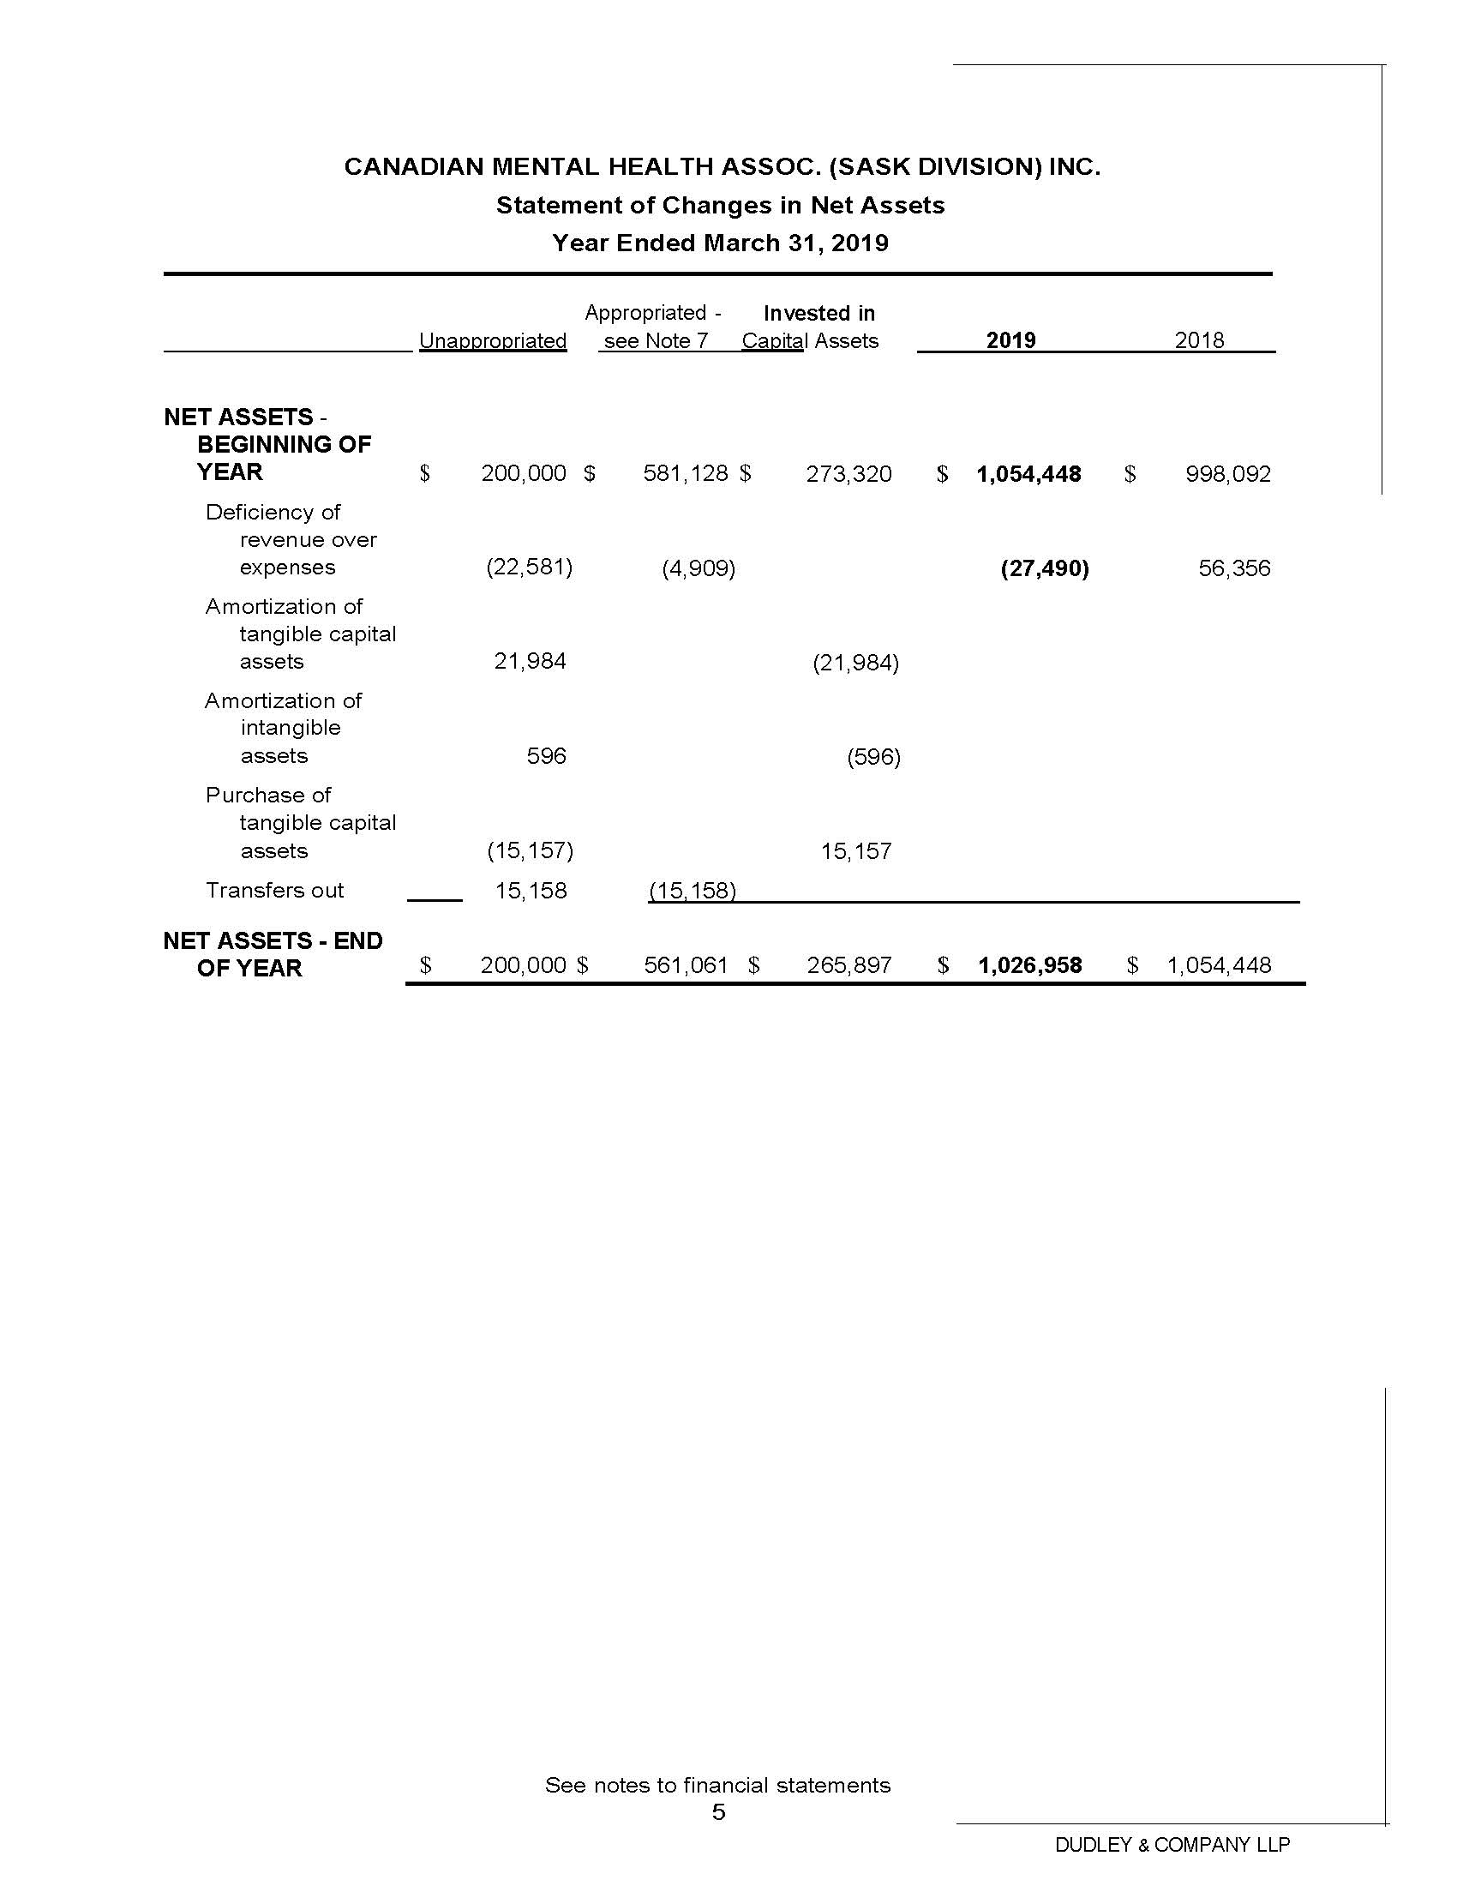

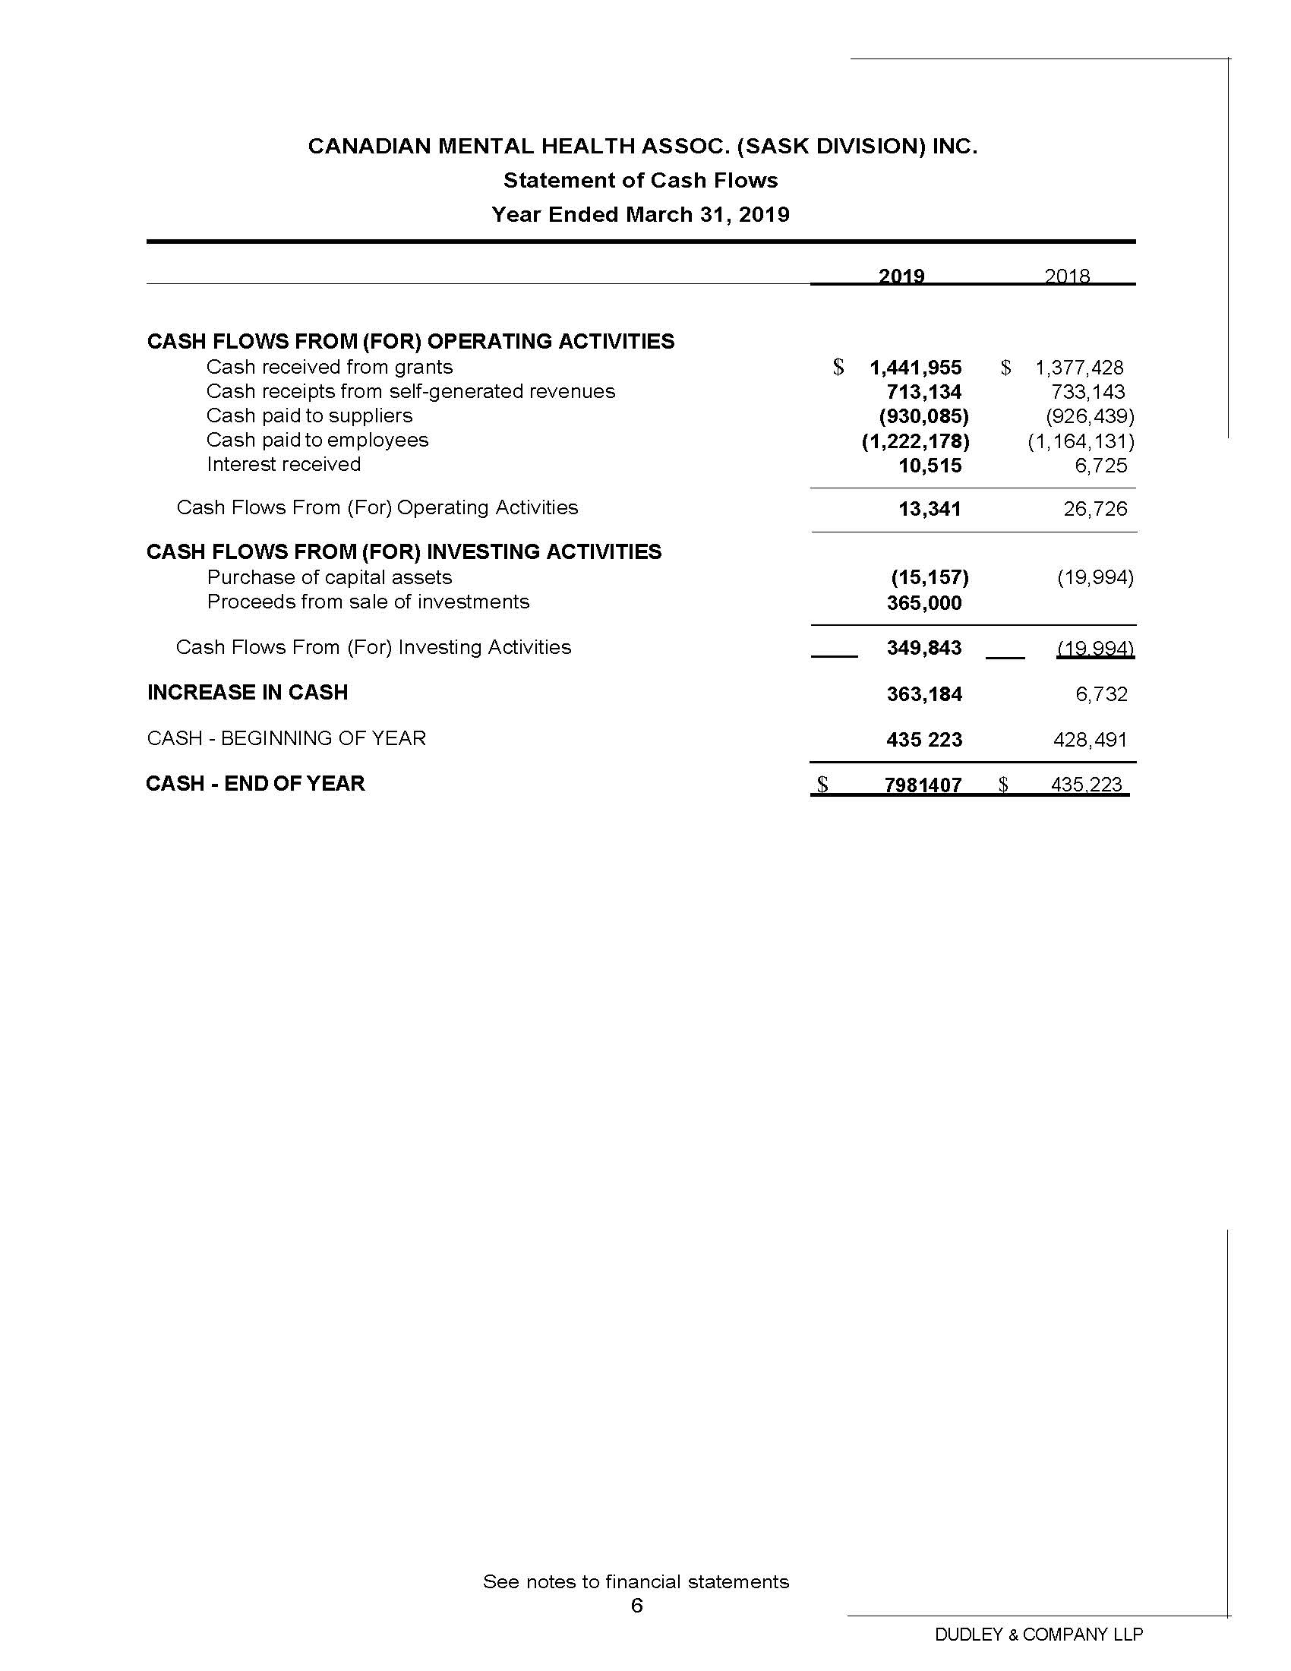

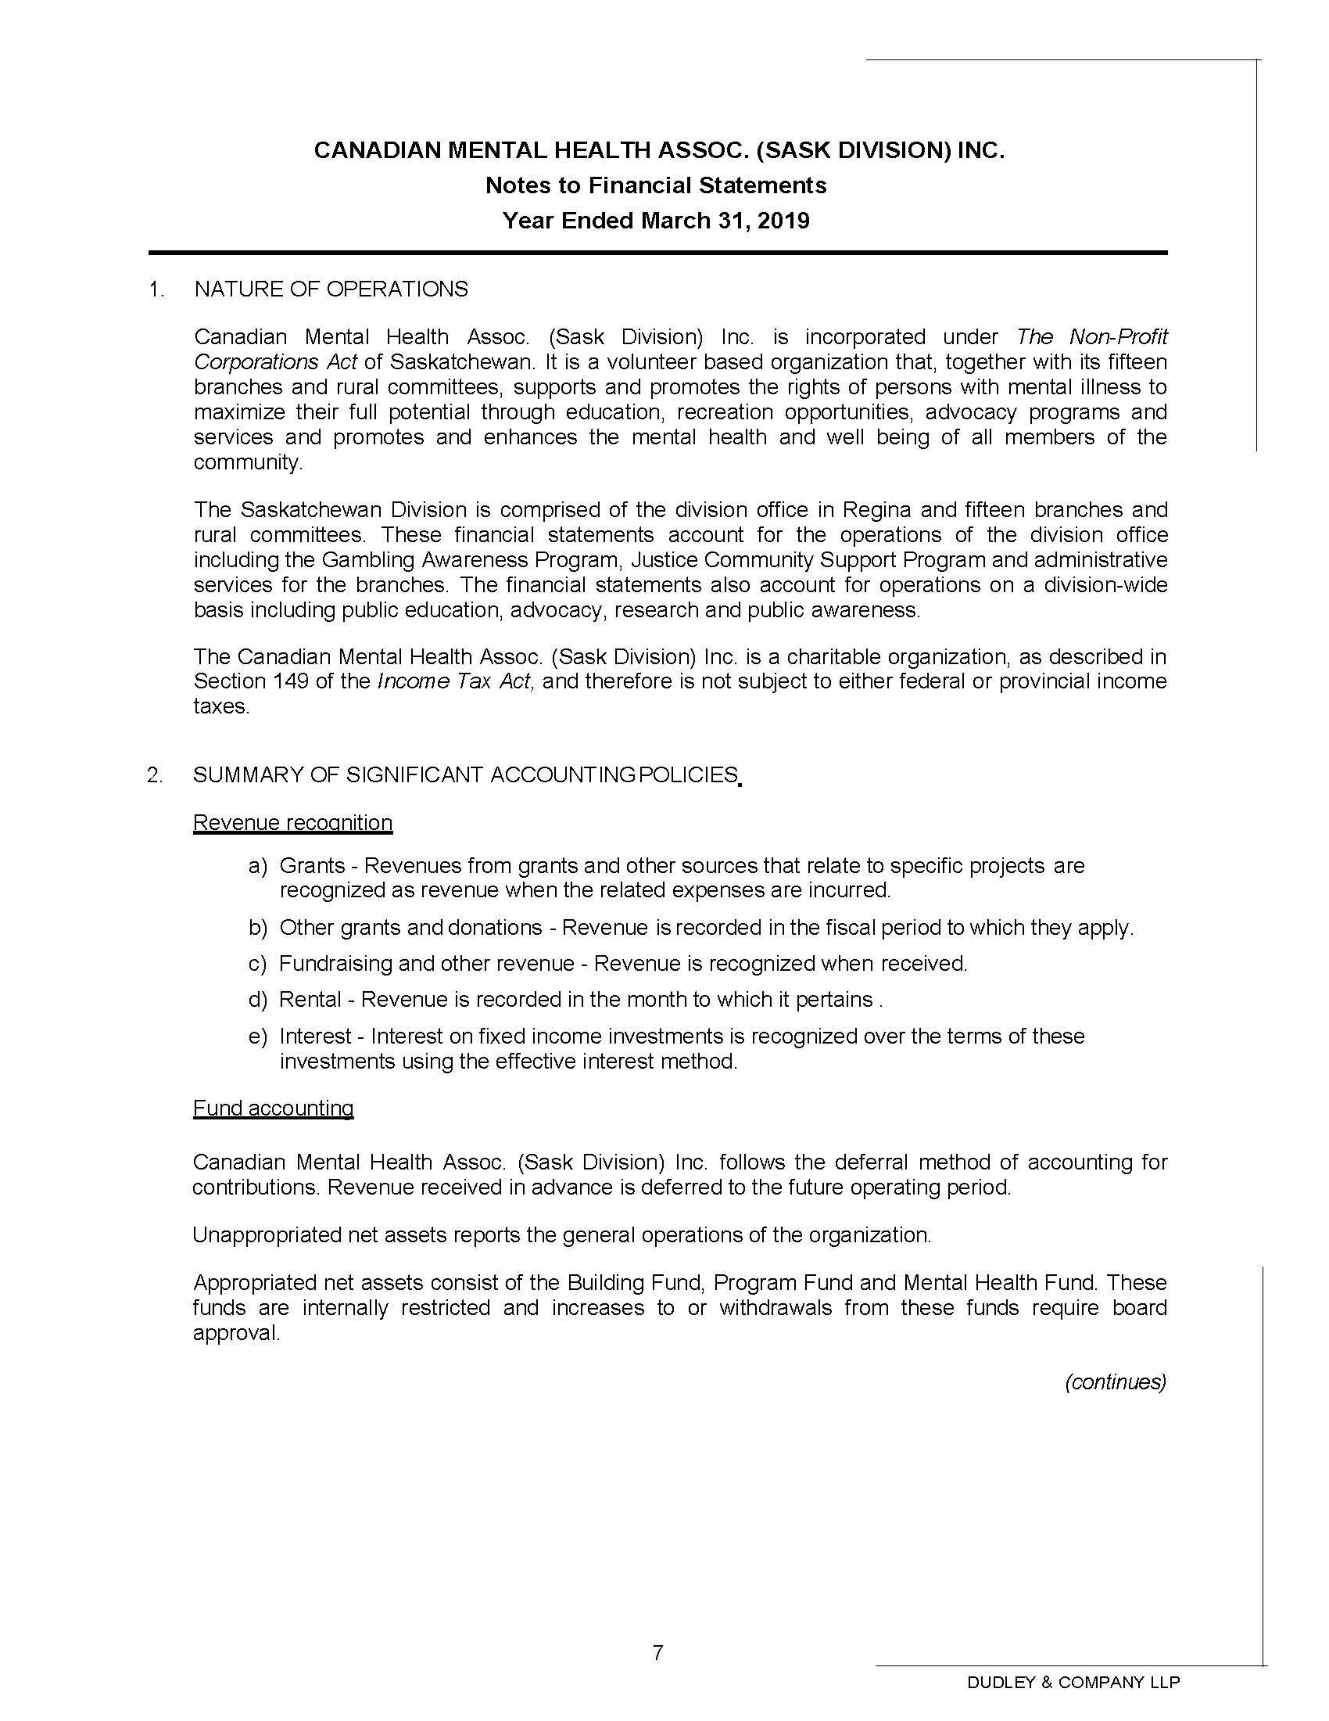

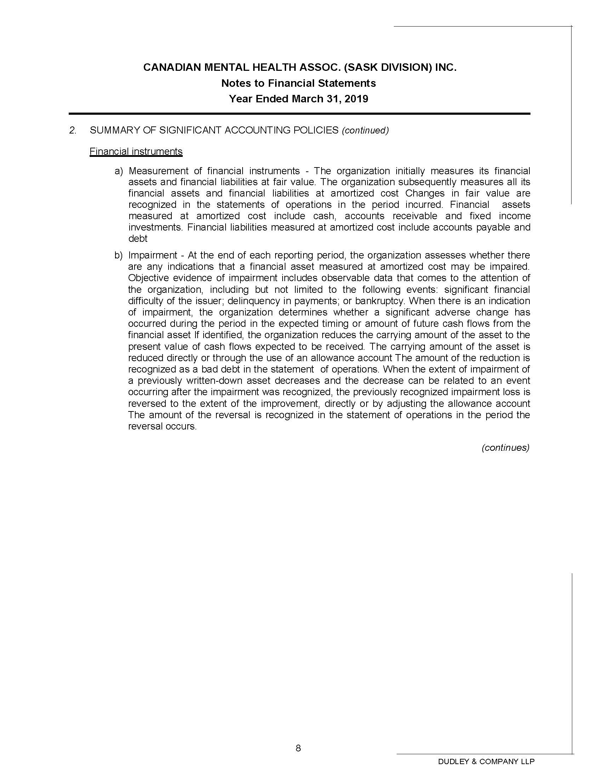

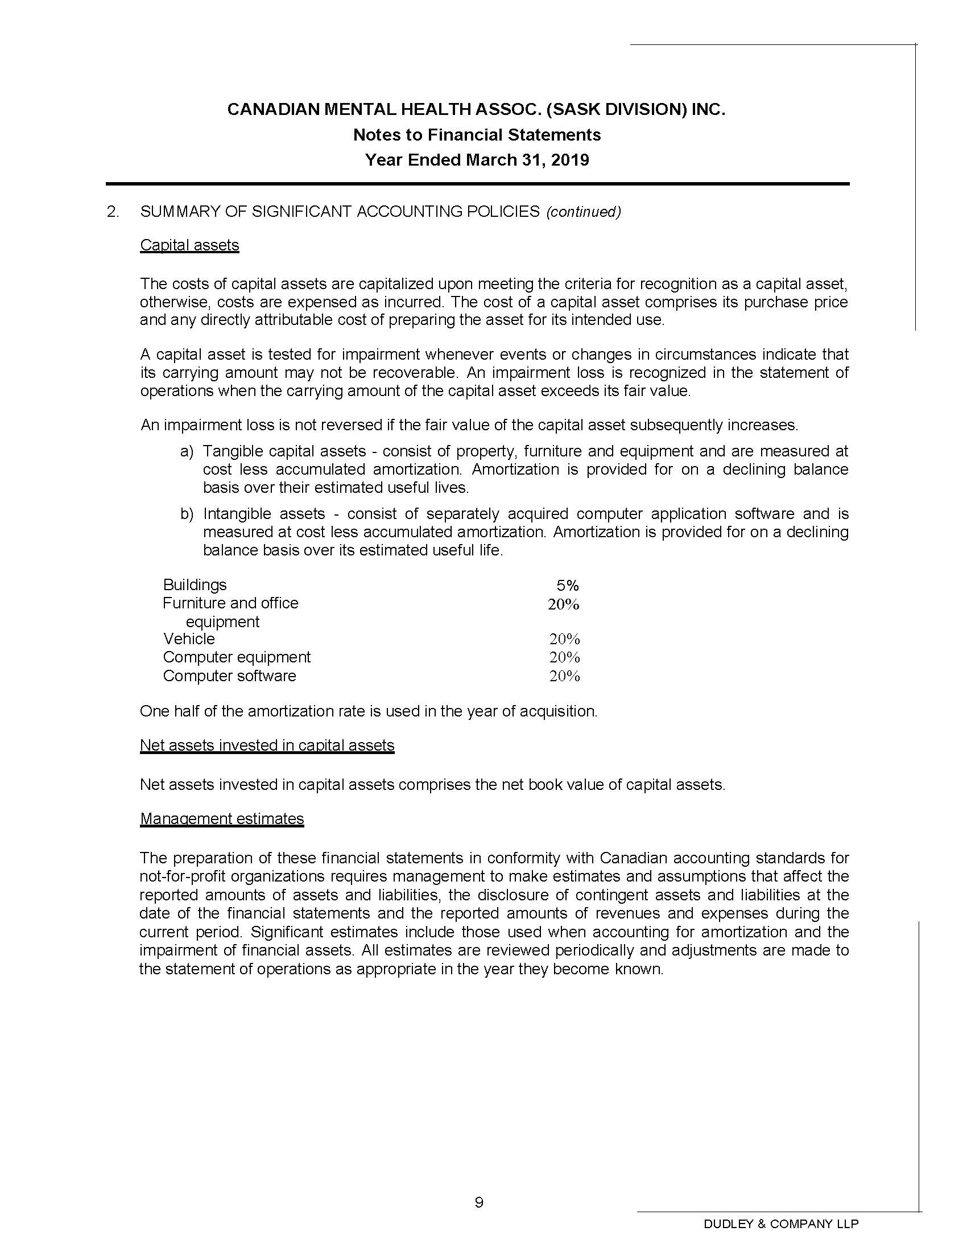

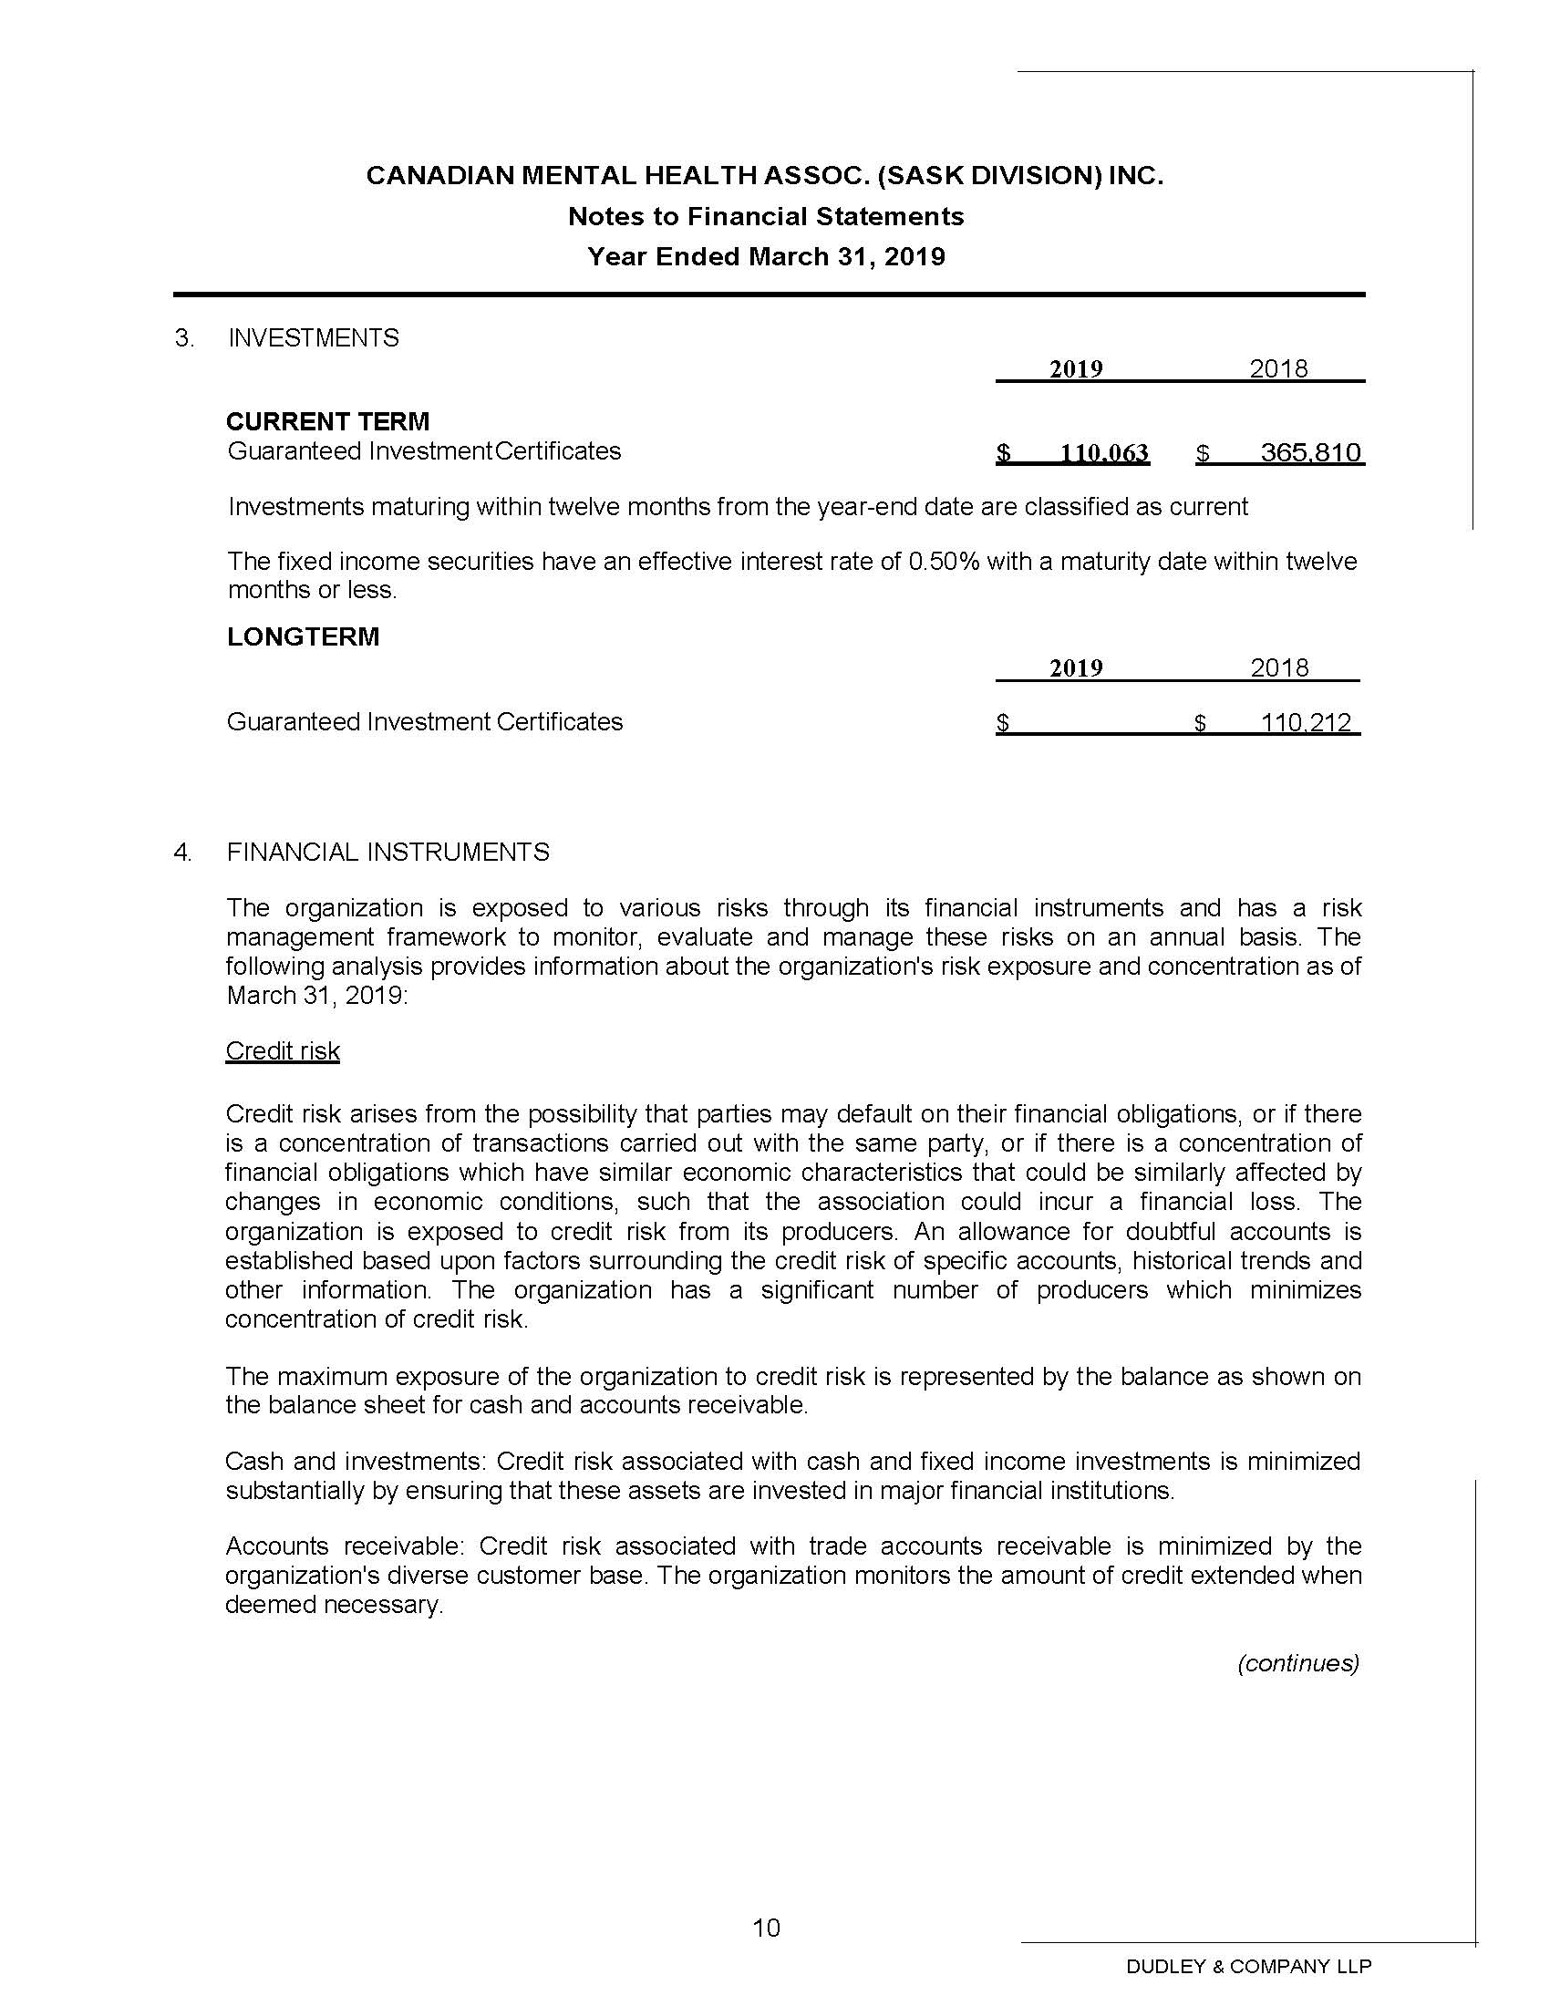

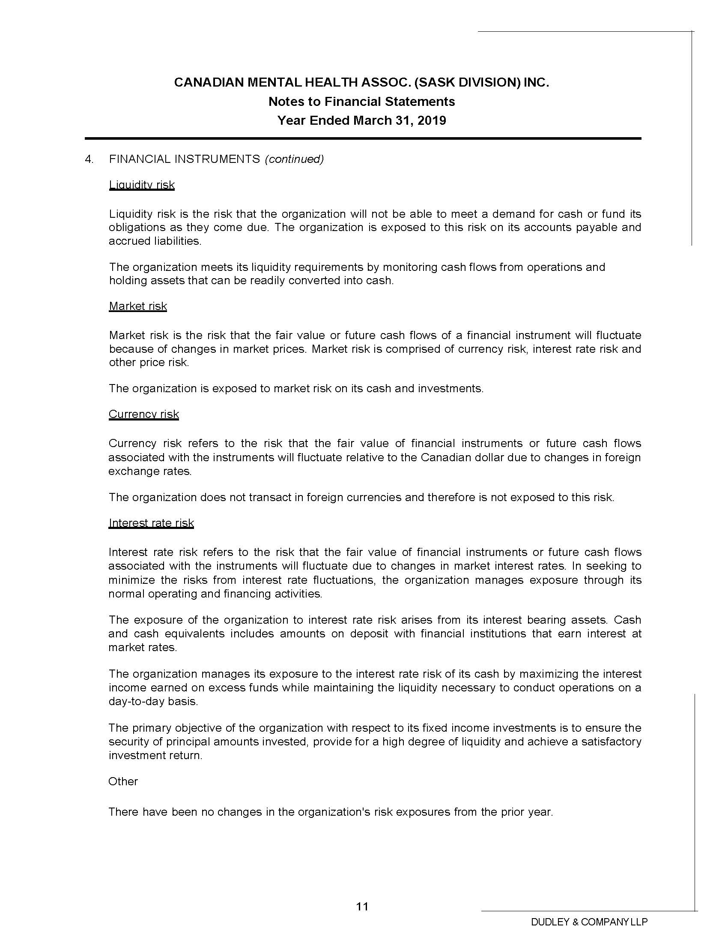

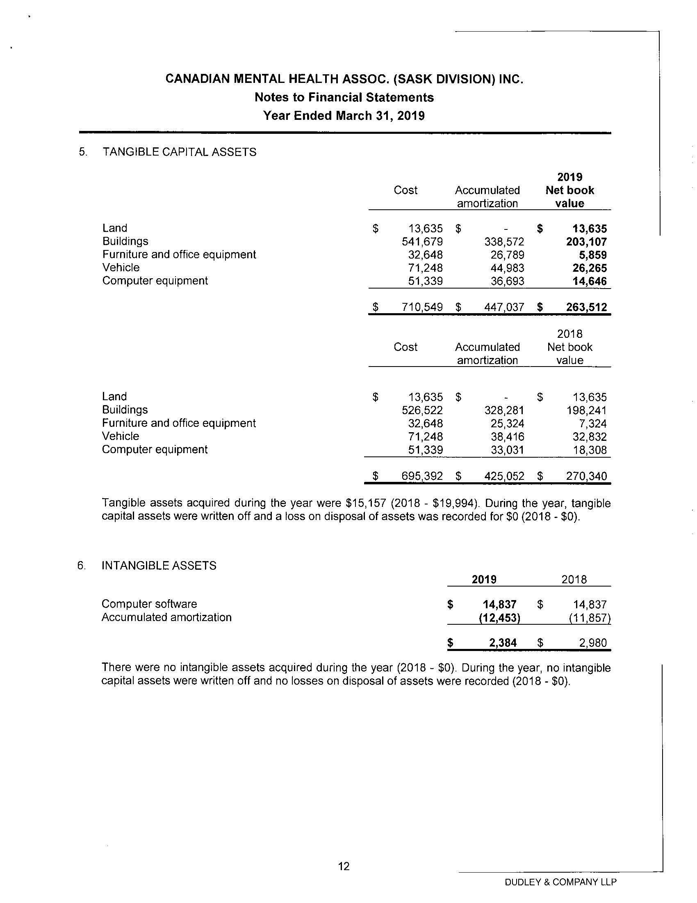

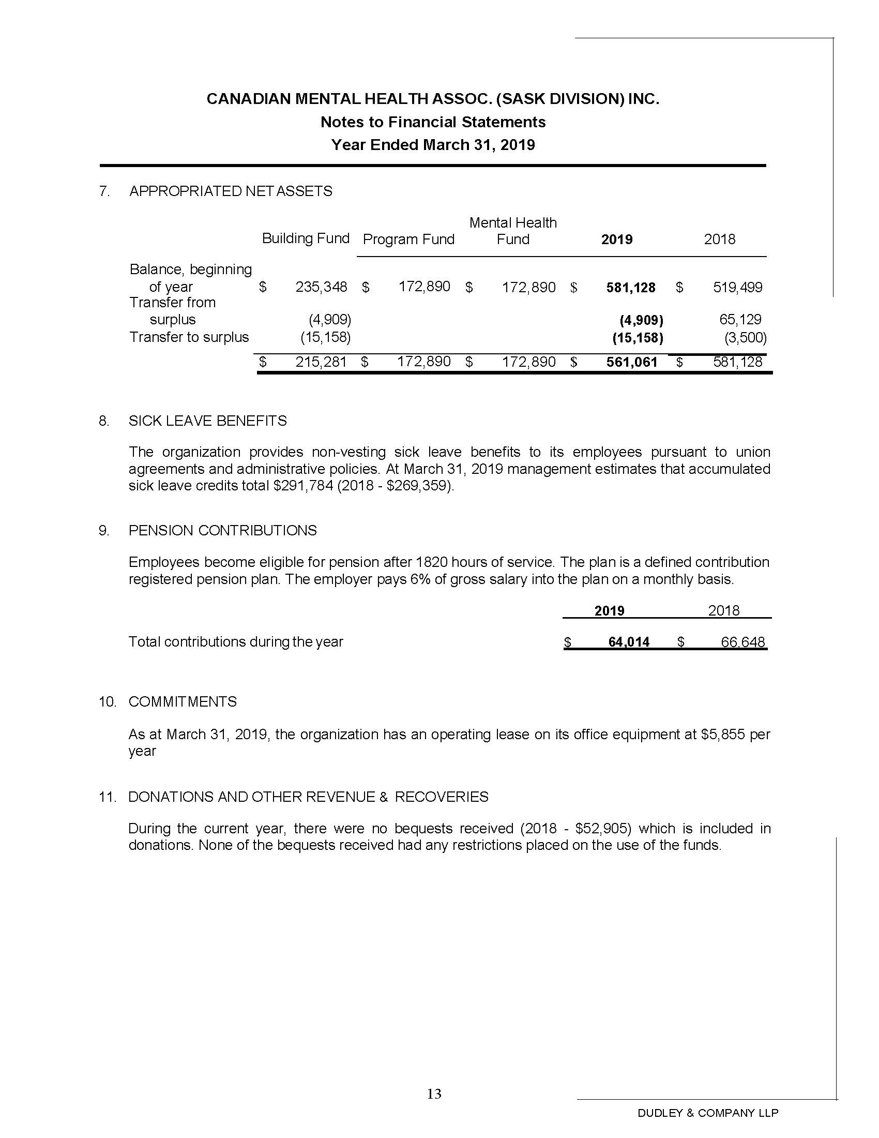
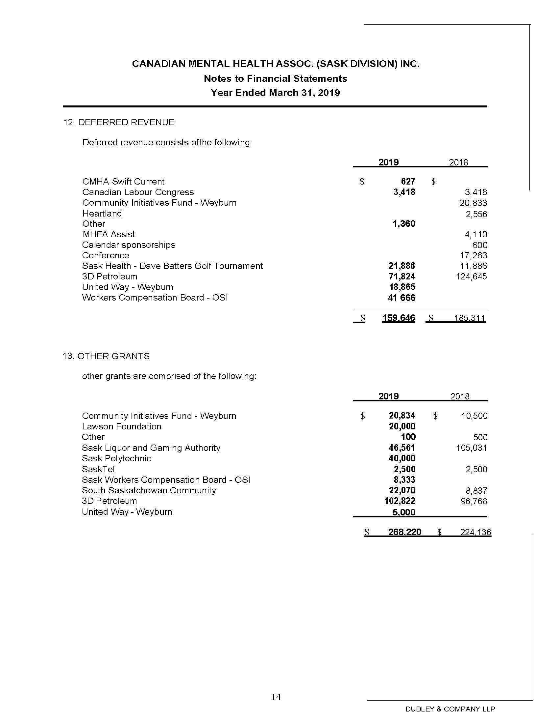

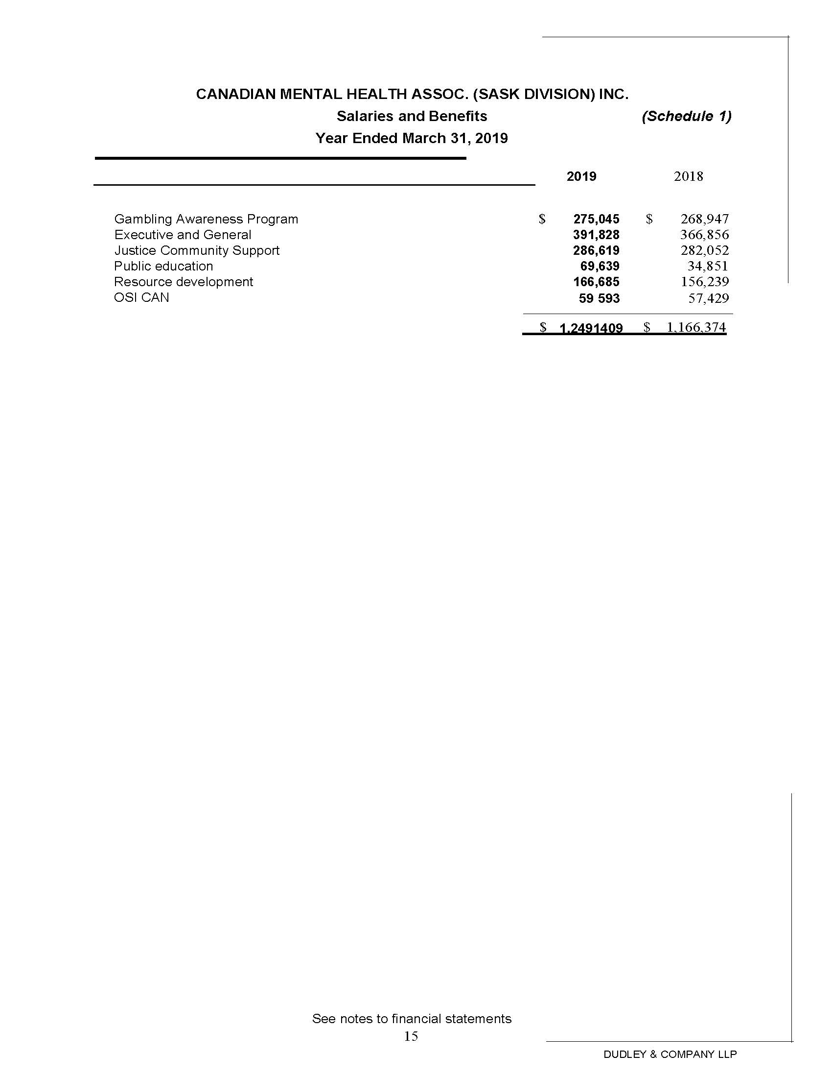

The Canadian Mental Health Association (Saskatchewan Division) Inc. is a charitable organization dependent upon donations, memorial gifts and bequests,
United Way, Donors’ Choice and Saskatchewan Lotteries for support.

We want to express our sincere appreciation to our sponsors:

